

Nano Brief
In the Year of 2014, Ebatco will have an exhibition booth at several seminars, society meetings and tradeshows. If you are attending any of the following events:
- February 23rd-26th, Adhesion Society Meeting 2014, Bahia Resort, San Diego, CA *representing Kyowa Interface Science, Co. Ltd.
- February 26th, ASM International MN Chapter Seminar, Hennepin Technical College, Brooklyn Park, MN
- March 2nd – 6th, Booth #2560, Pittcon, McCormick Place, Chicago, IL
- April 28th – May 2nd, Booth #506, International Conference on Metallurgical Coatings and Thin Films, Town & Country Convention Center, San Diego, CA
- May 2nd, MMS Spring Symposium, Minnesota Science Museum, St. Paul, MN
- May 3rd – 8th, Booth #1039, SVC TechCon, Hyatt Regency Chicago, Chicago, IL
- October 12th – 16th, Booth #319, Materials Science & Technology 2014, David L. Lawrence Convention Center, Pittsburgh, PA
- November 3rd – 9th, Booth #607, International Symposium for Testing and Failure Analysis, Houston, TX

Please stop by our booth to discuss the incredible nano world of nanomaterials, nanodevices, nanoinstruments, and nano/micro scale surface characterization with our staff scientists. We hope to see you sometime soon!

Ebatco
As of 2014, Ebatco has expanded its operations and opened an office in Suzhou, China. Our new office is located at Guohua Building A303, Chongwen Road, #328 Xinghu Street in Suzhou Industrial Park, Jiangsu Province, China. The Ebatco Suzhou Office offers sales, marketing and technical support to our valued customers in the Great China Region including Main Land China, Hong Kong and Taiwan. Mr. Wei Yuan, Sales and Service Representative, is working full time at our Suzhou Office. Mr. Yuan is a graduate of Xi’an University of Technology with extensive knowledge and experience in industrial customer support and services. Prior to joining the Ebatco Suzhou Office, Mr. Yuan was a Pre/After-Sales Service Engineer for Universal Instrument Company and a Maintenance Engineer for Mektec Company. Mr. Yuan endeavors to provide the best service and support for our customers. Welcome onboard!

Case Study
Viscosity is a useful fluid parameter used to describe a fluid’s internal friction or resistance to motion. A large viscosity will require a large shear force to overcome the internal friction. Shear forces can occur during operations such as pouring, mixing, spreading, or spraying.

The internal friction arises from attractive forces between the molecules of the fluid. When a shear force is applied, it must overcome the intermolecular forces in order to move the liquid.

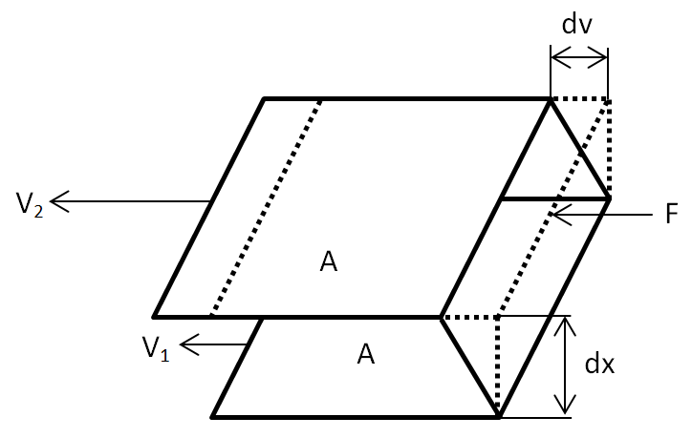

Newton defined viscosity, μ, by considering a situation like the figure above where two parallel planes of fluid of equal area, A, are separated by a distance, dx, and traveling at different velocities, V₁ and V₂. He assumed that the shear stress, τ, required to cause the difference in velocity was proportional to the change in velocity across dx, or the velocity gradient. Mathematically, it is expressed as the following equation:
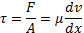

Fluids that behave according to the above equation are called Newtonian. Typical Newtonian fluids are water and thin lubricating oils.

Motor oil viscosity is an important factor to be considered for improving the performance and extending the lifetime of any engine. If the oil viscosity is too low, the lubrication layer between parts will be too thin to prevent engine parts from grinding against each other. However, if oil viscosity is too high, the oil may not pump properly during start-up when the engine is still cold. This requires that the correct viscosities of oils are used.

To facilitate this, oils are classified based on their viscosity and given a certification grade, such as 5, 10, 20, 30 40, or 50; these grades are defined by the Society of Automotive Engineers (SAE). Some oils are given two ratings, such as 5W-30, to indicate oil that has been treated with additives to flow like SAE 5 oil at start-up but SAE 30 after the engine reaches operating temperature. This allows for better engine performance and lifetime.

A 5W-30 motor oil was tested using a Brookfield LVDV-II+ Pro Viscometer. This viscometer has a measuring range of 1 cP to 6•10⁶ cP (1 cP is equal to 10⁻³ Pa•s). Coupled with appropriate temperature control equipment, the LVDV-II+ Pro provides excellent accuracy and repeatability in viscosity measurements at temperatures ranging from -20ºC to 300ºC. The measurement results are presented below.

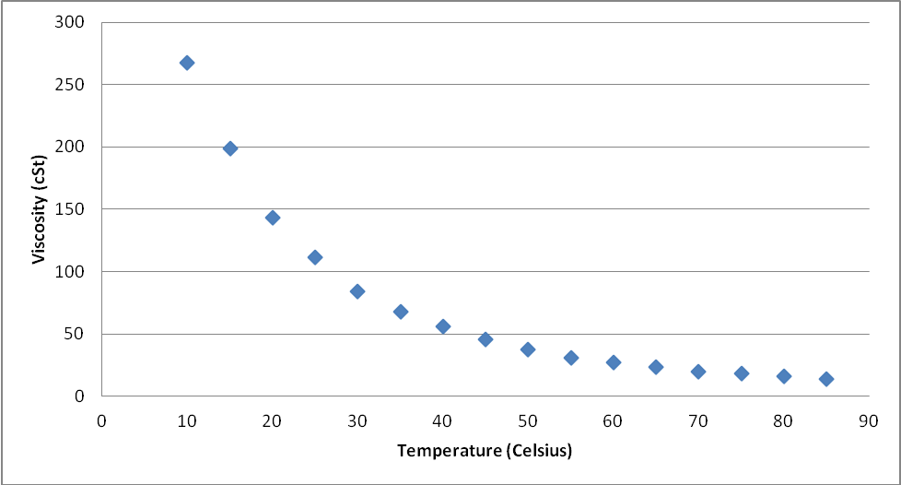

To subscribe or unsubscribe to this newsletter, contact info@ebatco.com.

Ebatco, 7154 Shady Oak Road, Eden Prairie, MN 55344
+1 952 746 8086 | info@ebatco.com | www.ebatco.com

