

Nano Brief
In the Year of 2015, Ebatco will have an exhibition booth at several upcoming seminars, society meetings and tradeshows with more to be announced later. If you are attending any of the following events:

- February 4th – 6th, Ink Jet Printing 2015 Conference, The Florida Hotel & Conference Center, Orlando, FL *representing Kyowa Interface Science, Co. Ltd.
- February 20th – 25th Adhesion Society Meeting 2015, Savannah Marriott Riverfront, Savannah, GA *representing Kyowa Interface Science, Co. Ltd.
- February 25th, ASM International MN Chapter Seminar, Hennepin Technical College, Brooklyn Park, MN
- April 20th – 24th, Booth #306, International Conference on Metallurgical Coatings and Thin Films, Town & Country Convention Center, San Diego, CA
- April 25th – 30th, Booth #906, SVC TechCon, Santa Clara Convention Center, Santa Clara, CA
- May 1st, MMS Spring Symposium, Minnesota Science Museum, St. Paul, MN

Please stop by our booth to discuss the incredible nano world of nanomaterials, nanodevices, nanoinstruments, and nano/micro scale surface characterization with our staff scientists. We hope to see you there!

Ebatco
Time flies! 2014 has marked the 7th year of successful business operations for Ebatco. We have been growing a little by little, exponentially, but still in the early segment of the curve. Congratulations and thanks to our hard-working employees, to our loyal customers and to our supportive principals, vendors, business partners and stake-holders. 2014 is the first year in which our China office became fully functional. In 2014, we have worked on more contract lab service projects than any year preceded it. We have had a great success in instrument product sales benefiting from the momentous economy recovery. We have had more interactions with our existing and potential customers through tradeshows, newsletters, customer satisfaction survey, website, conference presentations and scientific publications. For 2015, we have already set challenging goals and ambitious plans: more customers, more sales, acquisition of an optical profilometer for lab services, adding new staff to the sales and marketing department, ISO registration… We are looking forward to the 2015 new year. In the new year, please help us to help you to realize your new year’s resolution being it to develop a new product, to finalize or implement a new process, to solve a new challenging material related problem, to rapidly identify the root-cause of a failed part, or to reach a new career high! Call us and remember Ebatco whenever you have a technical challenge. We are here ready and willing to help!

Case Study
3D printing, or additive manufacturing, has been a hot topic in recent years. 3D printing is a layer-by-layer process of making solid three-dimensional objects from a digital file using a 3D printer. There are several different ways for implementation of 3D printing, differing mainly in the way layers are built to create the final object. One of them is printing by depositing molten materials through an extrusion nozzle. This fascinating technique relies on a material’s ability to flow at moderate temperature and pressure through a nozzle for extrusion of the molten materials as tiny droplets to a substrate. The adhesion tendency between the molten material and the nozzle and between the molten materials and a previously printed layer or a substrate is critical to the success of material transferring. One way to characterize the adhesion tendency is to perform contact angle measurement between the molten material and the substrate materials it will contact. In this case, the molten material needs to form a sessile drop out of the nozzle material and onto the substrate or the previously printed layer. Obviously, for this contact angle test a high-temperature testing environment is required.

Ebatco’s NAT Lab has provided contact angle measurement services for many years. The NAT Lab’s DM-701 Contact Angle Meter is equipped with high temperature accessories for measurements at elevated temperatures up to 380ºC. Separate controllers regulate the Heater Type Stage and Heater Type Dispenser. The Heater Type Dispenser includes a special glass syringe that can use either a 22G or an 18G needle. The molten materials are dispensed at the set temperature with a micrometer head for a controlled volume. The solid sample is heated to the desired temperature using a Heater Type of Stage before the commencement of the contact angle measurement.

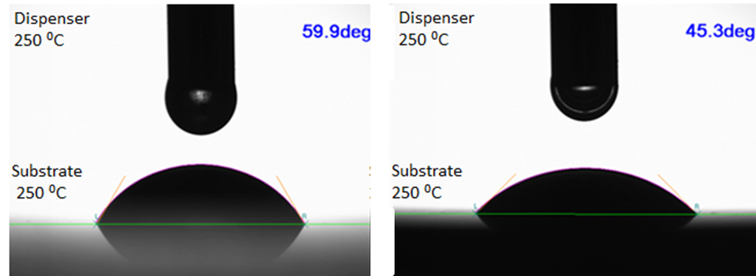
Optical images that were used for contact angle measurements between molten polystyrene droplet and glass (left), and between molten polystyrene and stainless steel (right).

Polystyrene is one of the common materials used for injection molding due to its fluidity, low shrinkage and good inherent thermal stability. Here, polystyrene has been selected to demonstrate high temperature contact angle measurement. The measurement substrate materials are glass and stainless steel. Before the droplet deposition, the substrate and the dispenser were heated to the set temperatures and allowed to equilibrate for a few minutes. The molten polymer was manually pushed through an 18G needle to form a pendant drop with volume approximately 3.5 µL. Then the molten polymer was deposited and transferred onto the heated substrate. The images of the droplets were captured and recorded by a camera and the contact angles were analyzed through the analysis software. The above figure shows two optical images of the molten polystyrene at high temperature on glass and stainless steel substrates for contact angle measurements.

From the analysis results, it is known that the molten polystyrene has different wetting characteristics on the two substrates at elevated temperature. At 250ºC, the contact angle of polystyrene with glass is 59.9º, and the contact angle of polystyrene with stainless steel is 45.3º. From the wetting and adhesion point of view, stainless steel would be a better printing substrate than glass.
To subscribe or unsubscribe to this newsletter, contact info@ebatco.com.

Ebatco, 7154 Shady Oak Road, Eden Prairie, MN 55344
+1 952 746 8086 | info@ebatco.com | www.ebatco.com

