

Nano Brief
In 2017, Ebatco will have an exhibition booth at several upcoming (and past) seminars, society meetings and tradeshows with more to be announced later. If you are attending any of the following events:

- February 22nd, ASM International MN Chapter Seminar, Hennepin Technical College, Brooklyn Park, MN
- February 26th – March 1, 40th Annual Adhesion Society Meeting, Hilton St. Petersburg Bayfront, St. Petersburg, FL *representing Kyowa Interface Science, Co. Ltd.
- April 29th – May 4th Society of Vacuum Coatings TechCon, Rhode Island Convention Center, Providence, RI
- May 5th, Minnesota Microscopy Society Spring Symposium, Minnesota Science Museum, St. Paul, MN
- October 2nd – 4th, BioInterface Workshop & Symposium, Catamaran Resort, San Diego, CA
- October 9th – 12th, Materials Science & Technology 2017, David L. Lawrence Convention Center, Pittsburgh, PA

Please stop by our booth to discuss the incredible nano world of nanomaterials, nanodevices, nanoinstruments, and nano/micro scale surface characterization with our staff scientists. We hope to see you there!

Ebatco
We are excited to announce our upcoming open-house to commemorate the 10 year anniversary of Ebatco’s founding. The open house will be held on Wednesday, June 28, 2017 at our Headquarters in Eden Prairie, MN. Year after year, Ebatco continues to reach new heights and grow our success. We would like to congratulate and thank our hard-working employees, our loyal customers and our supportive principals, vendors, business partners and stake-holders. In 2016, we have provided more contract laboratory services than any year previously. We have had more interactions with our existing and potential customers through tradeshows, exhibitions, newsletters, conference presentations and scientific publications. For 2017, we have already set challenging goals and ambitious plans: increasing customer base, increasing sales, expanding range of testing equipment, adding new staff members, and ISO 17025 Accreditation. In the new year, we are ready to assist your company to develop a new product, finalize or implement a new process, solve a challenging material related problem, or rapidly identify the root-cause of a failed part. Make sure to call Ebatco with any technical challenge you might be facing. Just remember, we KNOW nano!

As we continue to grow our business we have hired on new talent to expand our technical laboratory services. Please join us to welcome Mr. Anthony Cartwright, the newest addition to our technical team.

Mr. Anthony Cartwright holds a Master’s Degree in Nanoscience and Functional Nanomaterials from the University of Bristol in the United Kingdom. He specializes in analytical surface science and characterization techniques for high-tech materials applications. He looks forward to working with Ebatco to develop novel solutions to unique scientific and engineering challenges.

Case Study
Particles suspended in liquids are in Brownian motion due to random collisions with solvent molecules. This motion causes the particles to diffuse through the medium. The diffusion coefficient, D, is inversely proportional to the particle size according to the Stokes-Einstein equation:
$$D=\frac{k_{B}T}{3{\text{πη}}_{0}d}$$

Where D is the diffusion constant, k_{B} the Boltzmann’s constant, T the absolute temperature, ƞ₀ the viscosity, d the spherical particle diameter. Photon Correlation Spectroscopy (PCS), sometimes also referred as dynamic light scattering, is a technique used to determine the diffusion coefficient of small particles in a liquid. The coefficient is determined by accurately measuring the light scattering intensity of the particles as a function of time. As the particles of interest diffuse through the sample cell due to Brownian motion, an incident beam of laser light illuminates the particles. The particles scatter the light, producing fluctuations in the scattering intensity as a function of time. The scattered light is collected at a chosen angle, and is measured by a highly sensitive detector. Since the diffusion rate of particles is determined by their size, information about their size is contained in the rate of fluctuation of the scattered light. The intensity fluctuations are collected as photon counts and correlated to generate the auto correlation function (ACF). The diffusion coefficient is determined by fitting the ACF using the Cumulants method from which the mean size is obtained using the Stokes-Einstein equation.

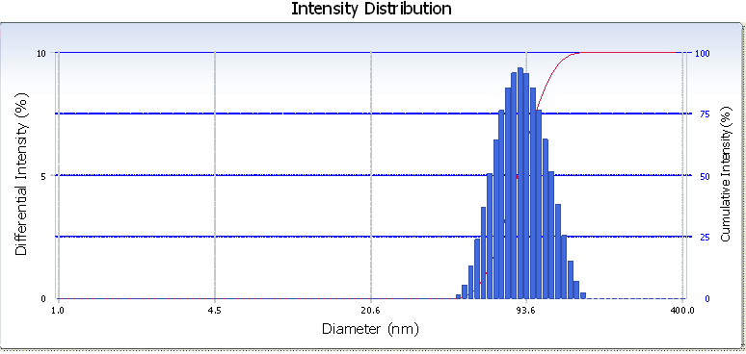
Figure 1. Intensity distribution of silica nanoparticles in solution used to determine the particle size.

The particle sizing tests can be performed on a Delsa Nano C Nanoparticle Size and Zeta Potential Analyzer available in Ebatco’s Nano Analytical and Testing Laboratory (NAT Lab). The Delsa Nano C utilizes Photon Correlation Spectroscopy and Electrophoretic Light Scattering techniques to determine particle size and zeta potential of materials. Offering an excellent degree of accuracy, resolution and reproducibility, the Delsa Nano C has been designed to simplify submicron particle size and zeta potential analyses. The Delsa Nano C provides accurate size measurements in the range from 0.6 nm to 7 μm with sample concentration ranging from 0.001% to 40%. It can perform the analysis of aqueous and non-aqueous samples as well as Zeta potentials of solid surfaces and membranes. The system is also equipped with a temperature control unit and an auto titrator to facilitate the study of temperature and pH value influences on particle size and agglomeration.

Table 1 Particle Sizing Measurement Results Obtained on Two Kinds of Metallurgical Polishing Slurries

Specimen | Diamond in Water  (nm) | Diluted Silica  (nm)
Test 1 | 4630.2 | 128.5
Test 2 | 4836.1 | 131.0
Test 3 | 4885.9 | 129.0
Average | 4784.1 | 129.5
Standard Deviation | 135.6 | 1.3

Particle size is a key characteristic in fields where size control is necessary. For example, polishing slurries can be used to create ultra-smooth surfaces. Large polishing particles can either create large unwanted scratches or not polish at all if the particle size is not controlled. Particle sizing can also be used to monitor the dispersion of drugs in pharmaceuticals. Particle sizing using dynamic light scattering or PCS has been serving a wide variety of applications in industries such as nanotechnology, electronics, pharmaceuticals, inks, food and beverage, biomedical, and textile.

Figure 1 and Table 1 are the measurement results obtained on two kinds of metallurgical polishing slurries using the Delsa Nano C Nanoparticle Size and Zeta Potential Analyzer.
To subscribe or unsubscribe to this newsletter, contact info@ebatco.com.

Ebatco, 7154 Shady Oak Road, Eden Prairie, MN 55344
+1 952 746 8086 | info@ebatco.com | www.ebatco.com

