

Nano Brief
In 2018, Ebatco will have an exhibition booth at several upcoming seminars, society meetings and tradeshows with more to be announced later. If you are attending any of the following events:

- February 28th, ASM International MN Chapter Seminar, Hennepin Technical College, Brooklyn Park, MN
- May 4th, Minnesota Microscopy Society Spring Symposium, Minnesota Science Museum, St. Paul, MN
- May 5th – May 10th, Society of Vacuum Coaters TechCon, Gaylord Palms Resort and Convention Center, Orlando, FL
- May 20th – May 24th, STLE 73rd Annual Meeting and Exhibition, Minneapolis Convention Center, MN
- June 13th – June 15th, 11th International Symposium on Contact Angle, Wettability, and Adhesion, Stevens Institute of Technology, Hoboken, NJ
- October 1st – 3rd, BioInterface Workshop & Symposium, St. Julien Hotel, Boulder, CO
- October 14th – 18th, Materials Science & Technology 2018, Greater Columbus Convention Center, Columbus, OH

Please stop by our booth to discuss the incredible nano world of nanomaterials, nanodevices, nanoinstruments, and nano/micro scale surface characterization with our staff scientists. We hope to see you there!

Ebatco
We are pleased to announce that Ebatco has just installed an Agilent Cary 600 Series FTIR system. This powerful characterization tool is composed of two main parts, a spectrometer and microscope. The Cary 670 FTIR spectrometer uses an air-cooled ceramic filament as a mid-IR radiation source that is passed through a 60° air-bearing Michaelson interferometer and an extended range KBr beam splitter. The IR signal is detected on a cooled/ambient DLaTGS detector. Using its current setup, Ebatco’s Cary 670 FTIR spectrometer has a maximum, usable transmission window of 375 cm⁻¹ – 6000 cm⁻¹. Additionally, a Pike MIRacle Attenuated Total Reflection (ATR) assembly can be inserted directly into the IR beam path of the main FTIR unit to be used with powder and liquid samples. The ATR is outfitted with a diamond crystal with a ZnSe lens that has a spectral range of approximately 400 cm⁻¹ – 4,000 cm⁻¹. The instrument is capable of recording spectra at spectral resolutions from 0.09 cm⁻¹ to 32 cm⁻¹.

The system not only functions as an FTIR spectrometer, but also includes the Cary 620 FTIR microscope. Complete with 4x, 15x, and 25x objectives, the microscope (and its apertures) allows for selected area imaging, in which signal can be selectively blocked or allowed from particular areas of interest. The 15x objective can be modified with an ATR accessory to perform selected area ATR imaging. Additionally, the microscope is equipped with a 32 x 32 focal plane array (FPA) of detectors that allows fast area imaging be performed, and the microscope can collect upwards of 10,000 spectra in less than a minute. Through the addition of the FPA and the selected area imaging additions, the FTIR microscope is well-suited to handle almost any imaging project.

With its large variety of imaging and data acquisition modes, FTIR spectroscopy is widely popular among almost all industries. The technique is often used to qualify materials such as plastics, fillers, paints, blends, polymers, adhesives, and liquids. Additionally, FTIR is used for quantitative analysis, kinetic modeling, and quality control. While perhaps the bulk of industrial FTIR applications revolve around polymer/pharmaceutical/forensics analysis, the different uses of the instrument are almost limitless.

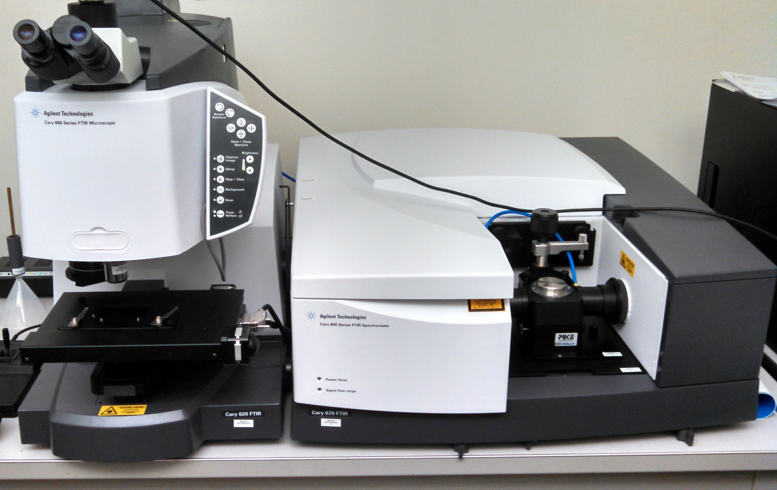
The Cary 620 FTIR Microscope (left) and Cary 670 FTIR Spectrometer and Pike MIRacle ATR accessory (right).

Case Study
A key element in proper forgery analysis or document verification is the ability to differentiate ink sources. Due to their ability to elucidate structural information without degrading the sample, both FTIR and Raman spectroscopy have become important workhorses in the field of ink and document analysis. They have even been used to identify the order in which inks are applied to a document and to determine the age of a document. Unfortunately, Raman characterization of inks is often impeded by the highly efficient process of luminescence. As such, the use of the longer wavelength provided by FTIR can be more insightful to differentiate inks that exhibit significant luminescence.

The most straightforward method to attenuate Raman-induced fluorescence is to change the laser excitation wavelength. Unfortunately, the intensity of Raman scattering (I_{RS}) varies inversely with the excitation source wavelength. Increasing the excitation wavelength by 2 fold would decrease the I_{RS} by 16 fold. Nevertheless, it is not uncommon to see lasers of either 785 or 1064 nm being used to perform ink characterization even considering the substantial signal loss. Additionally, increasing the laser wavelength changes the diffraction-limited laser spot diameter, effectively decreasing the resolution of the analysis.

Perhaps the easiest way to bypass luminescence is to avoid Raman spectroscopy altogether for some types of ink analysis. FTIR is a strong alternative to Raman, and by virtue of its infrared excitation source, spectra are not convoluted by luminescence. To illustrate the advantage of FTIR, a comparison of three Sharpie® inks on a substrate is shown in Figure 1. While the Raman spectra (Figure 1, left) give no structural information regarding the constituents of the ink, the FTIR spectra are much more informative (Figure 1, right).
Substrate
Black Ink
Green Ink
Red Ink
Figure 1. Three colored Sharpies were characterized using Raman (left) and FTIR (right) microscopy. Raman and FTIR spectra were collected using an excitation source of 532 nm and a ceramic filament, respectively.

To test the ability of the FTIR to differentiate unknown ink samples, three promotional black ballpoint pens were obtained from three different companies: Company A, B, and C. Because the pens were promotional (handed out at conferences or other events), it was unknown if the generic inks they contained were similar or not. As such, small pen strokes were generated on white printer paper and then were imaged using FTIR. The results are shown in Figure 2. Small shifts in peak locations and the development of new peaks are all used to differentiate one brand of ink from another. Important peaks for comparison are indicated with lines in Figure 2. No spectral shifts were applied prior to analysis.

As can be seen from Figure 2, the peak at 871 cm⁻¹ is constant among all samples except that it is absent for Company B. The spectral bands at 1160 cm⁻¹ shift for Companies B and C, the bands at 1360 cm⁻¹ and 1581 cm⁻¹ shift for Company A, and a new peak at 1656 cm⁻¹ is present for Company C. It should be noted that all pen strokes were characterized within one hour of being written. Thus, spectral differences are not resulting from time-dependent behaviors of carrier solvents, aromatic additives, or adhesives in the inks.

When analyzing inks or documents, nondestructive techniques are generally preferable to destructive techniques. Raman and FTIR spectroscopy are very well-suited to this end, and both exhibit the required sensitivity for accurate characterizations. When analyzing colored compounds, however, Raman scattering can easily become quenched by the overpowering and far more efficient process of fluorescence. As such, FTIR becomes a powerful alternative to characterize such samples as its IR excitation renders fluorescence contributions negligible. Furthermore, both Raman and IR signals are extremely sensitive to the surrounding environment of the atoms involved in the absorption or scattering of the excitation photons, and signal shifts down to 1 cm⁻¹ resolution can be observed.

Figure 2. Three pens from three companies (Company A, B, and C) were characterized by ATR-FTIR spectroscopy. Subtle differences in peak locations were used to differentiate one ink from another. Peaks originating solely from substrate remained constant from sample to sample, while the contributions from the ink induced unique signal shifts in the corresponding spectrum. Scan details: 128 scans/spectrum, spectral resolution = 4 cm⁻¹.
To subscribe or unsubscribe to this newsletter, contact info@ebatco.com.

Ebatco, 7154 Shady Oak Road, Eden Prairie, MN 55344
+1 952 746 8086 | info@ebatco.com | www.ebatco.com

