Nano Brief

In nanoscience news:

Researchers from Tel Aviv University have discovered, for the first time, a series of physical properties existing in polymer microfiber networks, among them "shape memory." These discoveries open the doors to a range of technological and biological applications, from tissue engineering to robotics. https://phys.org/news/2022-02-memory-hierarchical-networks-morphing-materials.html

Engineers at UC Berkeley have developed a new technique for making wearable sensors that enables medical researchers to prototype test new designs much faster and at a far lower cost than existing methods. https://phys.org/news/2022-02-technique-wearable-sensors-faster-costly.html

Ebatco

With growing customer base and increasing lab service demand, addition of new talents is warranted for Ebatco’s successful operations. In order to keep up with and better serve our customers’ needs, a new Office Administrator, Ann Krostrue, has just been hired on. Please join us in welcoming her on board.

Ann has a Bachelor’s degree in Journalism/Advertising from the University of Wisconsin–Eau Claire and joins the Ebatco team as our Office Administrator. She brings many years of administrative and customer service experience to support Ebatco’s daily operations. In her position, Ann performs duties such as office administration, answering phones, book keeping, invoicing, human resources and other business operation related duties.

Case Study

Characterization of Polyethylene Terephthalate (PET) Using Modulated Differential Scanning Calorimetry
Differential Scanning Calorimetry (DSC) is a very powerful tool in characterizing a broad range of materials. In a conventional DSC experiment, a material is heated and the total heat flow is measured. The change in heat flow can be analyzed to determine the temperatures of phase changes and other thermal events. While conventional DSC analysis is often sufficient to characterize pure materials, the analysis is often hindered by the occurrence of simultaneous thermal events, each of which influences the heat flow separately. While these simultaneous events are often observed in multicomponent systems such as polymer blends, composite materials, and alloyed metals, these events can manifest in single component systems as well. Using modulated DSC we are able to separate the events of these more complicated samples in order to determine what is occurring within the sample.
Modulated DSC is a thermal analysis technique that uses a sinusoidal temperature oscillation that deconvolutes the total heat flow curve into reversing and non-reversing components. The reversing heat flow component is sensitive to events that change the heat capacity of the material such as melting and glass transitions. The non-reversing heat flow is sensitive to kinetic events like curing, decomposition, and crystallization. This technique not only separates the heat flow components, but it is also more accurate at measuring heat capacity, crystallinity, and phase change temperatures.
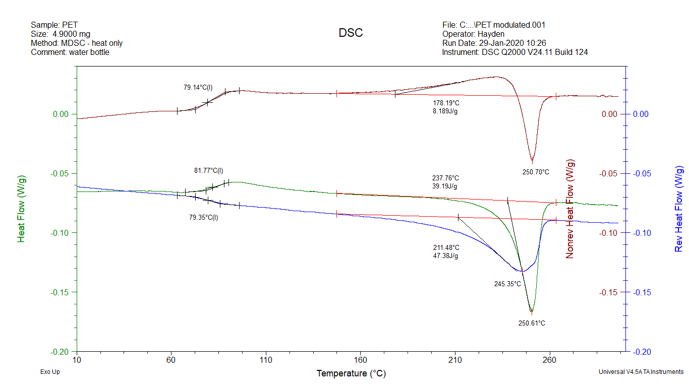
Figure 1. Modulated DSC thermogram of PET.
To illustrate the power of modulated DSC, Ebatco’s NAT Lab tested a sample of PET taken from a water bottle. The resulting DSC curves are shown in Figure 1. In Figure 1, the green curve represents the total heat flow measured. The curve is split up between the reversing heat flow (blue curve) and the non-reversing heat flow (red curve). The reference glass transition temperature of PET is between 70-80 ˚C and the melting temperature is 250 ˚C. From the total heat flow shown in Figure 1, the glass transition temperature is measured to be 81.77 ˚C and the melting point is 250.61 ˚C.
Normally the glass transition temperature is shown in a thermogram as an endothermic baseline shift, but this thermogram shows an exothermic baseline shift. The seemingly odd behavior is explained by examining the reversing and non-reversing heat flow. From these curves we can see that there are multiple events happening in the sample at the glass transition temperature. The reversing heat flow shows a normal glass transition event but the non-reversing heat flow has an exothermic baseline shift. This exothermic baseline shift in the non-reversing heat flow overcomes the endothermic baseline shift which results in the total heat flow showing an exothermic baseline shift instead of the expected endothermic baseline shift. Additionally, the glass transition temperature measured using the reversing heat flow, 79.35 ˚C, not only gives a more accurate value, but also a better understanding of what is happening as the sample is heated.
When examining the melting peaks, all of the heat flow curves show an endothermic peak around 250 ˚C. The reversing heat flow curve shows a much broader peak than the total and non-reversing heat flow curves. There is a slight exothermic event before the melting peak on the non-reversing heat flow curve. This offsets the broad melting peak on the reversing heat flow, which is why the total heat flow shows a sharp melting peak. The exothermic peak indicates that the PET sample is crystallizing as the melting is occurring.
To summarize, characterizing PET is a great example of how modulated DSC is useful to separate thermal events happening simultaneously in a sample. Whether the sample is a complicated composite or an everyday-use polymer, modulated DSC will be able to separate the thermal events to better characterize the sample.

To subscribe or unsubscribe to this newsletter, contact info@ebatco.com.

Ebatco, 10025 Valley View Road, Suite 150, Eden Prairie, MN 55344
+1 952 746 8086 | info@ebatco.com | www.ebatco.com

