Nano Brief
Magnesium is a promising candidate as an energy carrier for next-generation batteries. However, the cycling performance and capacity of magnesium batteries need to improve if they are to replace lithium-ion batteries. To this end, a research team focused on a novel cathode material with a spinel structure. Following extensive characterization and electrochemical performance experiments, they have found a specific composition that could open doors to high-performance magnesium rechargeable batteries. More on this exciting research news can be found at: https://www.sciencedaily.com/releases/2023/02/230209094127.htm.

Ebatco is ready to support the battery industry with a suite of testing for materials including cathodes, membranes, battery casings, coatings, adhesives, and more. This includes nanoscratch, macroscratch, nanoindentation, contact angle, pore size, Zeta potential, and more.

ETH Zurich researchers have developed an extraordinary protection coating against corrosion after a chance discovery. It glows in places where it is not damaged, repairs itself – and can be reused multiple times. More on this exciting research news can be found at:
https://ethz.ch/en/news-and-events/eth-news/news/2023/02/new-corrosion-protection-that-repairs-itself.html.

Ebatco offers many mechanical tests including nanoscratch, microscratch, and macroscratch for testing coatings like this one to observe and evaluate self-healing and self-repair capabilities.

Ebatco

As we continue to grow our business we have hired on new talents to expand our expertise and testing lab service offerings. Please join us in welcoming the newest addition to the Ebatco team: Mr. Reilly Thompson.

Mr. Reilly Thompson has a B.S. degree in Chemistry from Iowa State University. During his undergraduate education, he was a Research Assistant working in the area of biochemistry. His project focused on disease inoculation and soil yield analysis. Following his graduation, Reilly worked as Sales Representative for Norcraft Companies, Inc. He received rewards for Representative of the Year two times while working at the company.

As a Nano Analytical and Testing (NAT) Lab Technician of Ebatco, Reilly is looking forward to providing the best possible support to existing and prospective customers, and strive to serve as a bridge between Ebatco’s analytical expertise and customer’s needs.

Case Study

Tensile Testing of Metal Foils
Metallic foils are an important part of many products we use every day, such as moisture barriers in food and medical packaging, anti-static bags to protect electronics, or simply decorative shine added to a product. Thicker sheets of metals are used even more ubiquitously; in aluminum beverage cans, sheet metal furnishings and storage containers, razor blades, automotive body panels, and many more other applications. Mechanical properties are one of the reasons these metallic sheets and foils are selected for their applications. The mechanical properties of bulk metallic specimens are generally known and are relatively easy to measure. However, the bulk properties may not be readily usable for the thin sheet and foil applications because the cold-rolling process of forming a thin sheet or foil may significantly modify these mechanical properties. For example, cold-working of metals drastically changes metals’ grain structures and adds high concentrations of defects. Subsequent annealing, joining, welding, or bending would also modify the properties of metals even further. Since the mechanical properties of a metallic sheet or a foil are going to be significantly different from its bulk format, it is necessary to measure the mechanical properties of the sheet or the foil after all of the processing has been completed.

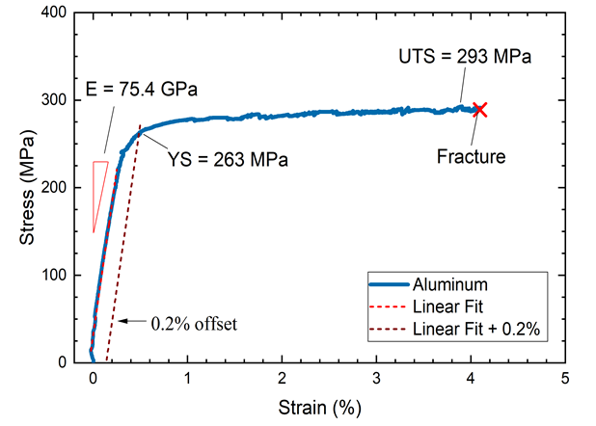
Figure 1. Typical stress-strain curve for an aluminum foil.

Tensile testing of metallic foils or sheets characterizes several useful and practical mechanical properties: the elastic modulus, yield strength, ultimate tensile strength (UTS) and ductility of a material. In this application note, the mechanical properties of three metallic foils were measured using tensile testing on a Shimadzu AGX-V Universal Testing Machine (UTM). The AGX-V UTM can apply forces from 0.1 N to 10,000 N at speeds from 0.5 μm/min to 3,000 mm/min, making it well-suited for testing composites, biomaterials, textiles, polymers, and thin metallic or ceramic materials. It fills a niche between microscale testing in DMA and macroscale tensile testers suited for bulk materials. Instead of being constrained by traditional clip-mounted extensiometers which are too heavy for thin foils to support, a duo TRView optical extensiometer cameras use image analysis to measure the displacement between gauge marks drawn or adhered to the sample. This setup also permits the simultaneous measurement of Poisson’s ratio by measuring the reduction of the sample width during tensile testing.

The three metal foils were selected and tested in accordance with ASTM E345. They are stainless steel, aluminum, and copper foils and were cut into 12.5 mm x 230 mm strips. Each sample had a 170 mm inter-grip distance and two gauge marks were placed on the sample to recognize a gauge length of 125 mm. Five samples of each foil material were tested. The sample width and thickness were measured to 1 µm accuracy using a micrometer. A strain rate of 0.8%/min was chosen such that the stress application rate was kept below 12 MPa/sec.

Figure 2 shows typical stress-strain curves of the stainless steel, aluminum, and copper foil specimens. The tensile elastic modulus, E, is measured from the slope of the linear portion of the stress-strain curve. Table 1 lists the average elastic modulus, yield stress, UTS, and extension at failure for the three specimen types. The copper foil clearly has the largest extension at failure, which is consistent with its superior ductility. While stainless steel has the largest UTS, its ductility is relatively poor and fractures almost immediately after the yield point.

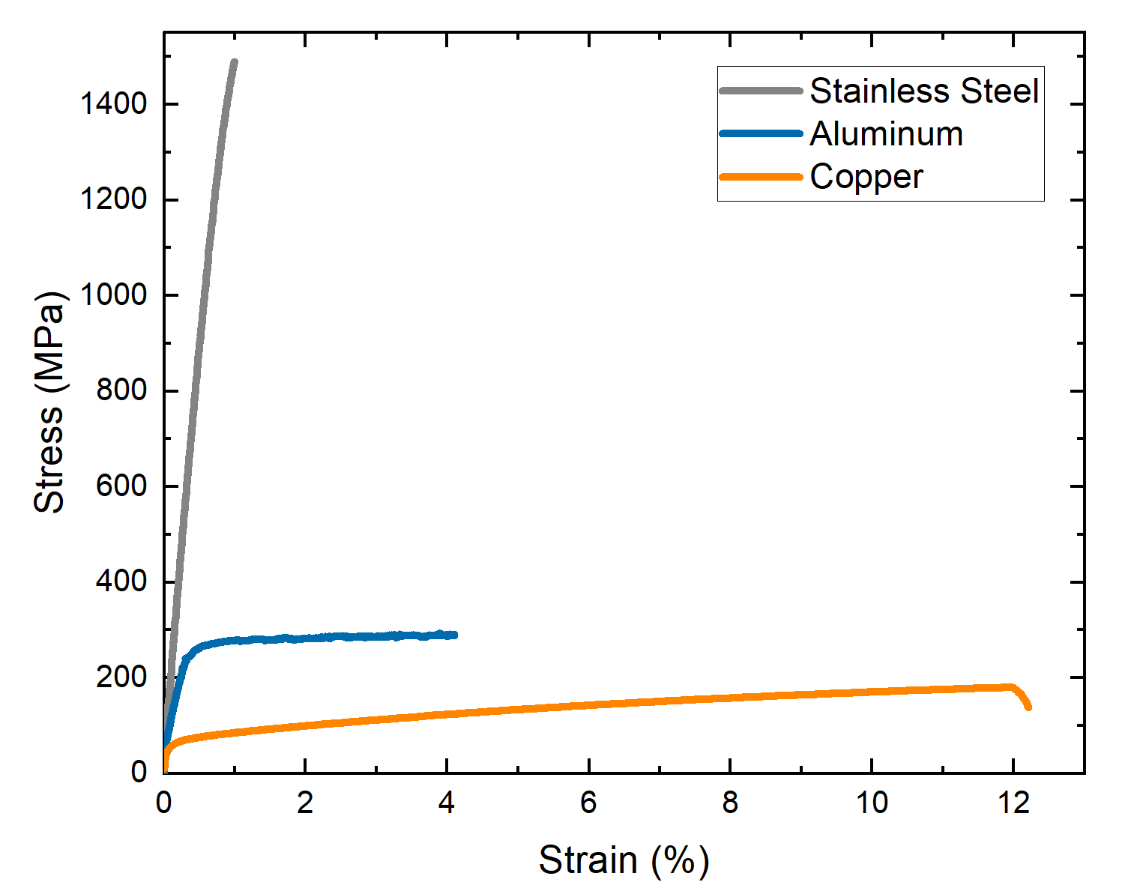
Figure 2. Typical stress-strain curves of stainless steel, aluminum, and copper foils.

Table 1 Tensile Mechanical Property Measurement Results for Metallic Foils
Specimen Material | Elastic Modulus  (GPa) | Yield Stress  (MPa) | UTS  (MPa) | Max. Elongation (%)
302 Stainless Steel | 178.81 ± 15.35 | 1446.04 ± 22.83 | 1550.86 ± 35.62 | 1.28 ± .17
Aluminum | 72.45 ± 7.66 | 251.70 ± 17.00 | 287.02 ± 3.34 | 3.21 ± 1.02
Copper | 122.79 ± 31.08 | 78.16 ± 9.72 | 197.23 ± 20.19 | 14.06 ± 3.63

Tensile testing of metallic foils is essential to determining the mechanical properties of the materials in thin sheet or foil formats after all processing steps have been completed. The results can be used to aid in product design with accurate property information, and to determine the effectiveness of heat treatments, variations between lots of the same material, and to help in process optimization. Non-contact camera-based extensometer is proven to be helpful in tensile testing of thin sheet and foil specimens that could not support clip-on extensometers.

To subscribe or unsubscribe to this newsletter, contact info@ebatco.com.

Ebatco, 10025 Valley View Road, Suite 150, Eden Prairie, MN 55344
+1 952 746 8086 | info@ebatco.com | www.ebatco.com

