Nano Brief

To keep pace with market needs, and to meet and greet our existing and potential customers, in 2024, Ebatco will participate in several regional and national conferences and exhibitions. With more to be announced later, Ebatco will present and exhibit at the following upcoming events:

- March 21 – ASM International MN Chapter 2024 Symposium: Materials Failure Analysis, Hennepin Technical College, Brooklyn Park, MN.
- April 19 – Minnesota Microscopy Society Spring Symposium: Super Resolution and Beyond, Minnesota Landscape Arboretum, Chaska, MN. Ebatco President Dr. Dehua Yang will present “Microstructural Failure Analysis of Fractured Metallic Materials”.
- April 30-May 2 – American Coatings Show and Conference, Booth #217, Indiana Convention Center, Indianapolis, IN, representing Kyowa Interface Science Co. Ltd.
- May 4-9 – SVC Technical Conference, Booth #918, Hilton Chicago, Chicago, IL.
- May 19-23 – STLE Annual Meeting and Exhibition, Booth #609, Minneapolis Convention Center, Minneapolis, MN.
- July 9-11 – SEMICON West, Booth #6810, Moscone Center, San Francisco, CA.
- October 16-17 – MD&M Minneapolis, Booth #2838, Minneapolis Convention Center, Minneapolis, MN.

Please stop by our booth to discuss the incredible world of nanomaterials, nanodevices, nanoinstruments, and nano/micro scale surface characterization with our staff scientists. We hope to see you there!

Ebatco

As we continue to grow our business, we have hired on two new Nano Analytical and Testing Lab Technicians to strengthen our customer support and expand our technical laboratory services. Please join us in welcoming Jack Mathieu and Zach Bowman to the Ebatco team.

Jack graduated from Carleton College in Spring 2023 with a B.A. in Chemistry and Geology. As an undergraduate in chemistry, he participated in research into the electrodeposition of novel CuO semiconductors for photoelectric applications. In his geology studies, he worked to build a crosscovariance model of groundwater discharge in Carleton College’s arboretum.

Zach graduated from the University of Wisconsin – River Falls with a B.S. in Physics and a minor in Mathematics. As an undergraduate, he studied and practiced a broad range of topics in physics. His capstone project provided opportunities for him to use telescopes and CCD cameras to measure a change in apparent brightness from Polaris Aa, the North Star.

Both Jack and Zach are excited about the opportunities to apply what they have learned in college and university to real-world applications. They are looking forward to providing the best possible support and services to existing and prospective customers.

Case Study

Powder Contact Angle of Cosmetics

Powders are commonly found in daily life, and are essential to our way of living. From foods such as cocoa, spices, coffee, grains, to other industry products such as pigments, hybrid powders for improved corrosion resistance, polymer additives for coatings, metal powders for sintering, etc. In the personal care or beauty industry, body and cosmetic powders are a necessity of daily life.

Cosmetic foundations need to react with various liquids in different ways. The powders need to be waterproof in order to prevent smudging, running, or general removal of makeup. Alcohols are used in toners and makeup removers and need to have sufficient wetting in order to have affinity with the powder. Oil is also used in some makeup removers. Olive oil is used as a substitute for the natural oils that skin exudes as well as to show how the powder would interact with other cleaners. One such way of characterizing loose powder is through powder contact angle via compressed pellets.

Powder contact angle test is comprised of compressing the powder into a pellet and then testing on a goniometer with a desired test liquid. Compressing the powder is essential, if the loose powder is too fragile or bumpy, that would be detrimental to the test. The trick is to compress the powder into a flat pellet so that the surface is smooth, without cracks or pits. From there, a standard goniometer test is performed on the powder pellet.

For this application note, a drugstore brand of loose powder foundation makeup was compacted into pellets. The liquids chosen for contact angle measurements include water, ethyl alcohol, and olive oil. Table 1 lists the contact angles of the various liquids measured on the cosmetic powder pellets. It can be noted that both alcohol and olive oil have low contact angles with the foundation makeup while water has a high contact angle with it. This shows the cosmetic powder can be easily distributed on skin, easily removed by alcohol or oil-based makeup removers, and has water-resistant properties, making it an optimized foundation makeup product from wettability and removal point of view.

Table 1. Contact Angles of Various Liquids on a Cosmetic Powder Pellet
Test | Ethyl Alcohol | Water | Olive Oil
1 | 22.9 | 91.8 | 30.7
2 | 27.5 | 89.0 | 27.8
3 | 21.6 | 91.1 | 30.2
4 | 23.5 | 89.0 | 30.4
5 | 25.9 | 91.7 | 28.9
Average | 24.3 | 90.5 | 29.6
S. D. | 2.4 | 1.4 | 1.2

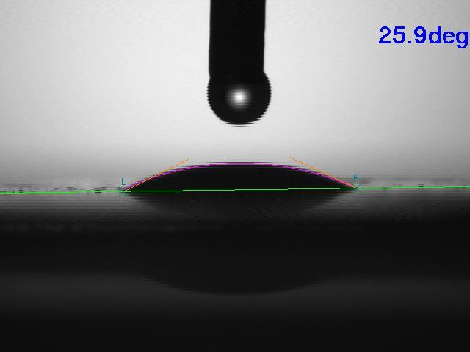
Figure 1. Image of an ethyl alcohol droplet on cosmetic powder pellet.

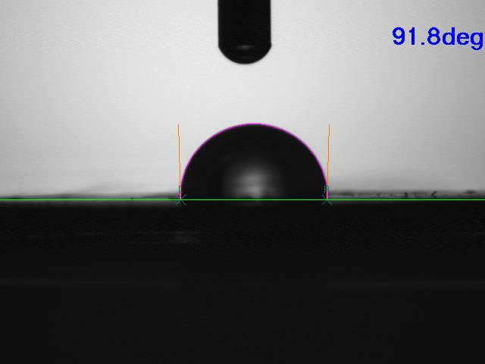
Figure 2. Image of a water droplet on cosmetic powder pellet.

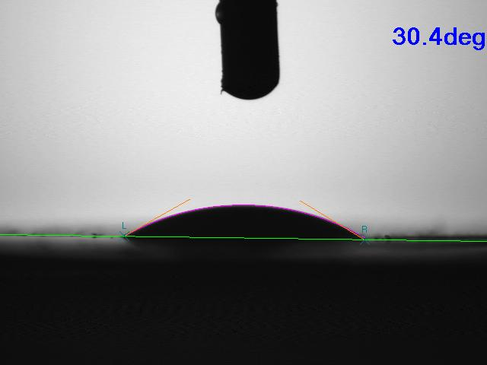
Figure 3. Image of an olive oil droplet on cosmetic powder pellet.

To subscribe or unsubscribe to this newsletter, contact info@ebatco.com.

Ebatco, 10025 Valley View Road, Suite 150, Eden Prairie, MN 55344, USA
+1 952 746 8086 | info@ebatco.com | www.ebatco.com

