

Nano Brief
Thank you to all of those who visited us at the Adhesion Society Meeting; the ASM International MN Chapter Seminar, Pittcon; the International Conference on Metallurgical Coatings and Thin Films; and the MMS Spring Symposium. In addition to the upcoming tradeshows, we will be representing Kyowa Interface Science at the Society of Tribologists and Lubrication Engineers Annual Meeting in Lake Buena Vista, Florida and at the Ninth International Symposium on Contact Angle, Wettability and Adhesion in Bethlehem, Pennsylvania. The updated list for our remaining events is as follows:

- May 3rd – 8th, Booth #1039, SVC TechCon, Hyatt Regency Chicago, Chicago, IL
- May 18th – 22nd, Booth #603, Society of Tribologists and Lubrication Engineers Annual Meeting, Disney’s Contemporary Resort, Lake Buena Vista, FL *representing Kyowa Interface Science, Co. Ltd.
- June 16th-18th, Ninth International Symposium on Contact Angle, Wettability and Adhesion, Lehigh University, Bethlehem, PA *representing Kyowa Interface Science, Co. Ltd.
- October 12th – 16th, Booth #319, Materials Science & Technology 2014, David L. Lawrence Convention Center, Pittsburgh, PA
- November 3rd – 9th, Booth #607, International Symposium for Testing and Failure Analysis, Houston, TX

Please stop by our booth to discuss the incredible nano world of nanomaterials, nanodevices, nanoinstruments, and nano/micro scale surface characterization with our staff scientists. We hope to see you there!

Ebatco
Having an online presence is important in today’s world of high-speed internet and smart mobile devices. Many companies go beyond simply having only a webpage and utilize specific online services like Facebook, Twitter and YouTube. Of these services, Ebatco has setup a YouTube channel to host a series of videos about the various testing and analysis methods offered by our NAT Lab. As of this moment, our YouTube channel consists of short videos covering nanoindentation, glass transition temperature, hardness conversion, non-Newtonian fluid testing and refractive index testing. We hope to upload more videos in the future covering other testing methodologies and instrument training. Our YouTube channel can be found at www.youtube.com/ebatco, so please keep an eye out for our upcoming videos.

Lifelong learning is a valuable principle that helps to better ourselves and be the best we can be. Following this, Ebatco’s staff scientists and engineers have been participating in voluntary training sessions to further master and broaden our knowledge of the equipment in our NAT Lab and of the equipment we are selling and marketing. These training sessions have expanded our understanding of differential scanning calorimetry (especially for polymers), scanning electron microscopy and the sandblasting systems for sales purposes.

Case Study
Pressure sensitive adhesives, or PSA, play an integral part of our daily lives. By forming a bond to a surface by means of pressure instead of relying on heat, water or a solvent to activate the adhesive allows for quick application when a need arises. Some of the applications for PSA include protective films, bandages, sticky notes, printed labels and tapes. PSA tapes come in a wide array of materials and adhesive strengths. One way to analyze the adhesive strength of such PSA tapes is through a Kyowa Versatile Peel Analyzer VPA series instrument. The VPA implements a sample stage adjustable to any desired angle between 0° and 180° and measures the peel strength under variable load and speed.

One use of the VPA is to understand a PSA tape’s peel strength dependency on peel angle. The peel angle is the angle formed between the surface of an adherend and the tape being peeled away. In the figure below, the peel strength of a PSA tape on a stainless steel plate was measured at 5° increments from 30° to 180° under a constant peel speed of 300 mm/min. As seen from the data, the peel strength of the tape reaches a minimum when the peel angle is set to 120°.

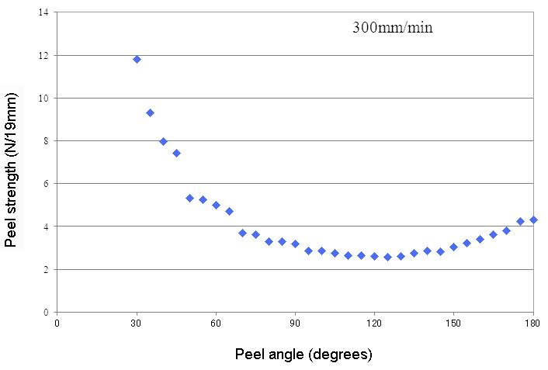
The relationship between peel strength and peel angle of PSA tape on stainless steel.
Another dependency of a PSA tape’s peel strength is the dependency on peel speed. The peel speed is the rate at which an adhesive tape is removed from an adherend. In the figure below, the peel strength of a PSA tape on aluminum and stainless steel plates were measured at 90° under peel speeds of 300, 600, 1200, 3000 and 6000 mm/min. As seen from the data, the peel strength of the tape increases with the peel speed for both the aluminum and stainless steel plates.

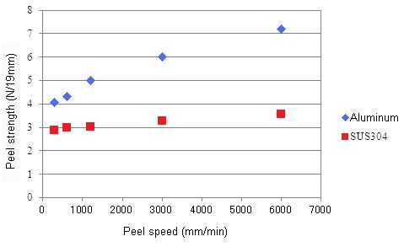
The relationship between peel strength and peel speed of PSA tape on aluminum and stainless steel.

To subscribe or unsubscribe to this newsletter, contact info@ebatco.com.

Ebatco, 7154 Shady Oak Road, Eden Prairie, MN 55344
+1 952 746 8086 | info@ebatco.com | www.ebatco.com

