

Nano Brief
Ebatco will be exhibiting at the Society of Vacuum Coaters TechCon 2017 on May 2 – May 3, 2017 at the Rhode Island Convention Center in Providence, Rhode Island. Please stop by our booth (#618) to discuss the incredible world of nanomaterials, nanodevices, nanoinstruments, and nano/micro scale surface characterization with our staff scientists. We hope to see you there!

Ebatco
The team at Ebatco would like to remind you of our upcoming Open House event! It will be held on Wednesday, June 28, 2017 at our Headquarters in Eden Prairie, MN. We hope you will attend and take the opportunity to meet local professionals and learn more about our company. Keep in mind there will be a door prize raffle given out at the event!! More information will be sent out in the near future with an itinerary for the event. On behalf of everyone at Ebatco we hope to see you there!



Our president, Dr. Dehua Yang, has been selected as a member of the 2018 Editorial Advisory Board for the Society of Tribologists and Lubrication Engineers’ magazine, Tribology & Lubrication Technology (TLT). The magazine is the official monthly publication of STLE and is created to aid in the technical education and professional development of STLE members and industry colleagues.

In his appointment letter, Mr. Thomas T. Astrene, Publisher, Society of Tribologists and Lubrication Engineers wrote: “Congratulations--I am pleased to let you know you have been named to TLT’s 2018 Editorial Advisory Board. This is no small honor…The review process was rigorous, and making the final choices was an extremely difficult task. Your selection was based entirely on your technical knowledge, years of experience and sterling reputation within the lubricants industry.”

Case Study
With computers having a large role in daily life, it is important to protect the hard drive as much as possible to minimize the risk of data loss. Hard drive manufacturers implement techniques such as take-off and landing zones for the head slider as well as magnetic locks for the actuator arm to help protect the hard drive. Even with such precautions, unexpected shock or vibration can cause the head to contact the hard drive platter, causing damage to magnetic recording layer on the disk. To prevent this, lubrication and diamond-like carbon (DLC) coatings are applied to the hard disk surface to protect the magnetic layer from crash damages and frictional wear.

Because both the lubrication layer and DLC coatings are on the order of tens of nanometers in thickness and the head slider is a very small and light device, thus, wear study of these coatings requires light contact loads and high sliding speeds. Ebatco NAT Lab’s TS-501 tribometer made by Kyowa is capable of carrying out such a challenging task. The TS-501 can operate under 5-500gf load at a speed up to 100mm/second in order to create a reciprocating wear track on the platter surface. The reciprocating wear test may be performed up to hundreds or even thousands of cycles along a single wear track. With the ability to use wear counterparts of different contact formats as well as to perform tests at light loads and a large number of cycles, the TS-501 is an excellent choice for evaluating the wear resistance and durability of the hard disk platter.

The data presented here is for a hard disk platter that underwent reciprocating wear tests using the TS-501. A sapphire ball of 3mm in diameter was used as the wear counterpart. A 10 mm stroke length, 20 gf load, 5mm/second sliding speed, and 700 or 1000 cycles were used for the wear tests. After the wear tests, three segments from each wear track were analyzed using scanning probe microscopy in order to determine the cross-sectional area of the wear tracks. From the cross sectional area and the stroke length, the wear volumes were determined. Knowing the wear volume, force and total sliding distance yields the wear rate of the hard disk platter under the selected wear testing conditions.

Table 1 Wear Test Results of a Hard Drive Disk
Test Cycles | Wear Cross  Section 1 (µm²) | Wear Cross  Section 2 (µm²) | Wear Cross  Section 3 (µm²) | Average (µm²) | Wear Volume (µm³) | Wear Rate  (m³/N*m)
700 | 0.335 | 0.397 | 0.216 | 0.316 | 3160 | 2.30*10⁻¹⁵
1000 | 0.531 | 0.470 | 0.323 | 0.441 | 4410 | 2.25*10⁻¹⁵

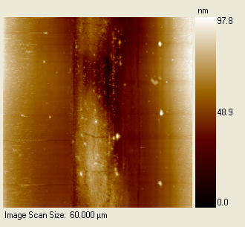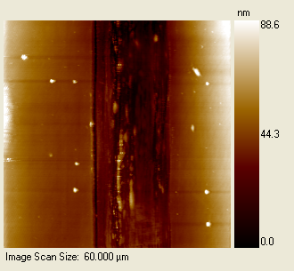
Figure 1. Scanning probe microscopy images of the 700 cycle (left) and 1000 cycle (right) wear tracks on a hard drive disk surface.

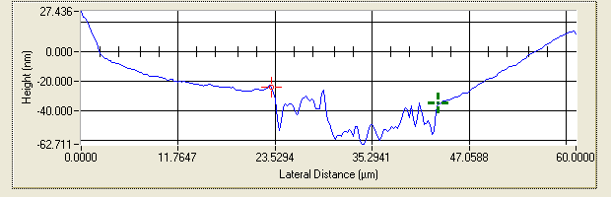
Figure 2. Line profile across the 1000 cycle wear track on a hard drive disk surface.

As exemplified above, light load, high speed reciprocating wear analysis is a very useful and effective approach to evaluate wear resistance and durability of ultra thin films, coatings and bulk material surfaces used in applications where contact force is low and sliding speed is high. These applications may include electrical switches, printer heads, printing papers, flooring materials, touch screens on electronics, and light load ball bearings.

To subscribe or unsubscribe to this newsletter, contact info@ebatco.com.

Ebatco, 7154 Shady Oak Road, Eden Prairie, MN 55344
+1 952 746 8086 | info@ebatco.com | www.ebatco.com

