

Nano Brief
Ebatco will be exhibiting at the Society of Vacuum Coaters TechCon 2018 on May 8th – May 9th at Gaylord Palms Resort and Convention Center, Orlando, Florida. Please stop by our booth (#340) to see and discuss how an ISO 17025 Accredited Testing Lab can help with your coating analysis needs.

Ebatco
We are happy to announce that Ebatco has successfully moved to a new larger facility. The new space will allow us to expand our testing capabilities as well as further meet your testing and analysis needs. Our new address is:

10025 Valley View Road, Suite 150, Eden Prairie, MN 55344, U.S.A.

Please update your address book and start to use the new address for us. All of our other information including our phone and fax numbers, email, and website will remain the same. We look forward to doing business with you from our new headquarters!

Case Study
The field of forensics often focuses around matching unknown samples to known samples. This idea applies to matching blood samples, hair samples, residue extracts, and many others. The same concept is also used in identifying counterfeit money, performing forgery analysis, and discovering illegal trade items by comparing suspected counterfeit imports to genuine imports. As such, any instrument that can discriminate subtle differences in structure, composition, or behavior will be invaluable to all of these fields. In regards to the ability to discriminate among surface structural features, atomic force microscopy (AFM) is one of the most powerful in elucidating such subtlety at the micro and nanoscale.

In its most straightforward form, AFM generates surface maps of a sample by rastering a small tip (typically nanometers in diameter) across a surface. As the tip moves across the surface of the sample, the tip will move up and down following fine surface contours while maintaining a constant contact force, and a detector is able to monitor the position of the tip as it traverses the peaks and valleys present on the surface of the sample. The Z height and X and Y position information are used to form a 3D structure map with nanometer resolution.

In this illustration of AFM, the surface structures of two hair samples were investigated: a cat hair and a human hair. The resulting images from the scans are shown in Figure 1. Differences in the two strands are immediately apparent. Human hair (Figure 1, left) grows in more linear sheets while cat hair grows with a more scale-like pattern. This difference is significant enough such that AFM can easily discriminate between hair samples from different species based on the different growth mechanisms present.

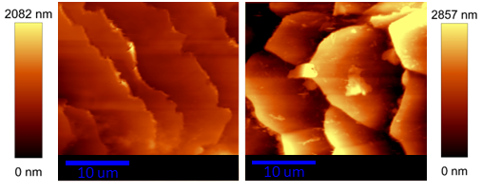
Figure 1. Topographical AFM images of two strands of hair: a human hair (left) and a cat hair (right). Hair strands were placed horizontally on the stage.

Furthermore, AFM is capable of generating extremely high resolution images, allowing users to obtain some highly specific structural information from samples. Using the cat hair sample, the 3D topographical images (Figure 2, right) clearly show the molecular orientation of the large keratin fibers that constitute the cat hair. It can be seen that the fibers grow parallel to the direction of the hair growth. AFM is thus a very powerful tool to obtain not only structural features, but also molecular information.

As known, AFM is capable of generating high resolution surface maps of almost any kind of sample, soft or hard. Additional non-contact or intermittent contact modes are often used for softer samples when direct contact mode is not well-suited to the sample. Because of the wide variety of imaging modes, AFM has numerous applications and the technique can be applied to a broad range of industries in addition to forensics.

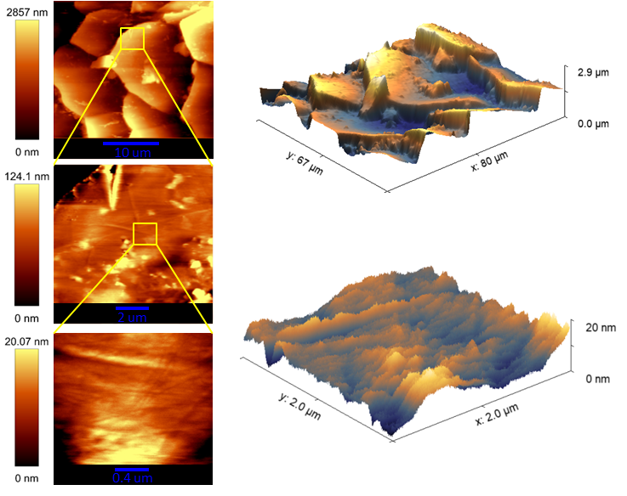
Figure 2. AFM images of cat hair obtained at three different zoom levels. 2D (left) and 3D topographical (right) images are shown. The bottom images even show the arrangement of the keratin fibers used to grow the hair.
To subscribe or unsubscribe to this newsletter, contact info@ebatco.com.

Ebatco, 10025 Valley View Road, Suite 150, Eden Prairie, MN 55344
+1 952 746 8086 | info@ebatco.com | www.ebatco.com

