Nano Brief

In nanoscience news:

Researchers at the USC Viterbi School of Engineering and Purdue University have developed a highly specialized 3D printing technique that allows microfluidic channels to be fabricated on chips at a precise microscale not previously achieved, according to Nature Communications.
https://viterbischool.usc.edu/news/2022/04/new-3d-printing-technique-a-game-changer-for-medical-testing-devices/

A research team from Kyoto University and other universities has succeeded for the first time in the world in developing an alloy that combines all eight elements known as precious metals, including gold, silver, and platinum, according to an announcement in the Journal of the American Chemical Society. The alloy is said to be 10 times more powerful than existing platinum as a catalyst for producing hydrogen from water by electrolysis. It may also lead to a solution to the energy problem, they hope.
https://mainichi.jp/articles/20220330/k00/00m/040/049000c

A nitrogen doped carbon-coated nickel anode can catalyze an essential reaction in hydrogen fuel cells at a fraction of the cost of the precious metals currently used, Cornell researchers have found. The new discovery could accelerate the widespread use of hydrogen fuel cells, which hold great promise as efficient, clean energy sources for vehicles and other applications.
https://news.cornell.edu/stories/2022/03/carbon-coated-nickel-enables-fuel-cell-free-precious-metals

Ebatco

Congratulations to Dr. Yang for having been invited to be a panelist for the 2022 May Forum! He will be speaking at the Creation and Innovation Panel of the forum. The forum’s Zoom meeting will be held on May 7th from 11:00 AM to 1:00 PM CDT and will feature Minnesota Governor Tim Walz, US Senator Tina Smith and other distinguished panelists. You can register and find more information for the forum at: https://mayforum.org/2022/04/2022-may-forum-coming-saturday-may-7th-to-celebrate-aapi-heritage-month-of-may-the-may-forum-group-mn-chinese-americans-here-is-link-to-2022-may-forum-zoom-meeting-sign-up/.

The Ebatco newly acquired Shimadzu Universal Testing Machine has been fully installed, tested and calibrated! It is ready to serve your needs of tensile, compression, shear, bending and other mechanical testing!

Another new addition to our chemical analysis instrument suite is the brand-new Agilent 5900 ICP-OES. With both axial and radial plasma viewing capabilities, the instrument can perform trace element analysis down to parts per billion (ppb) levels or bulk chemical analysis due to the instrument’s wide linear dynamic range. The addition of the SPS 4 Autosampler to the instrument increases automation and productivity, minimizes user intervention, and leads to higher reproducibility of measurements. Moreover, the ability of the instrument to monitor and record several wavelengths from a single element simultaneously minimizes the risk of interfering signals, and increasing the accuracy of the measurement results. The ICP-OES can also perform a quick screening analysis and provide concentration estimates of up to 70 elements using the IntelliQuant Analysis software.

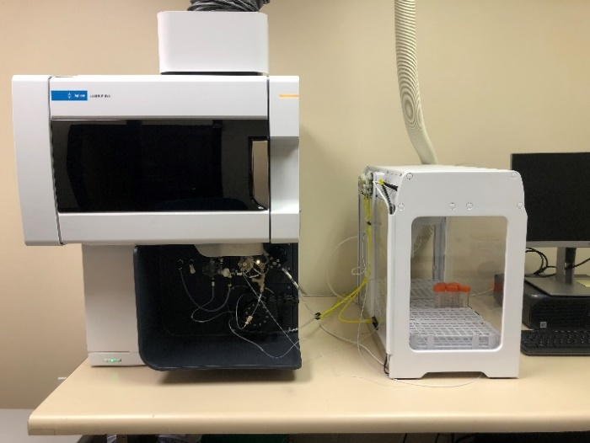

The Agilent 5900 ICP-OES with the SPS 4 autosampler.

Case Study

Quantifying the Elemental Composition of Materials Using ICP-OES
Inductively coupled plasma optical emission spectroscopy (ICP-OES) is an indispensable tool in the determination of elemental composition and concentration down to parts per billion levels in a wide range of sample types. In applications ranging from steel manufacturing to environmental testing to contaminant quantification, it is imperative to accurately determine the elemental composition of a sample. Given this, ICP-OES is an ideal tool to perform quality control, as well as R&D.
ICP-OES is a spectroscopic technique that excites atoms and ions and measures the wavelength of the emitted light when electrons return to their lower energy level. To accomplish this, specimens are nebulized and introduced into a high temperature argon plasma. This plasma provides enough energy to excite the atoms, whose emission rays are then measured by a detector. Due to the technique’s ability to measure multiple wavelengths of a single element, as well as utilize methods such as internal standardization and inter-element correction, even samples containing a high number of analytes at varying concentrations can be accurately analyzed.
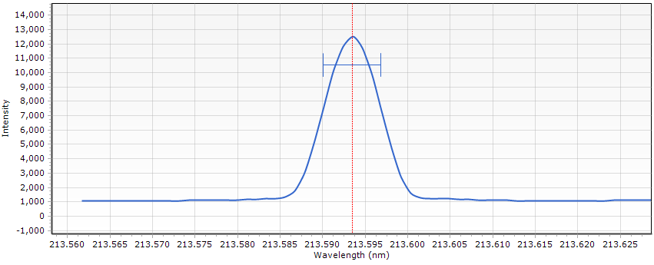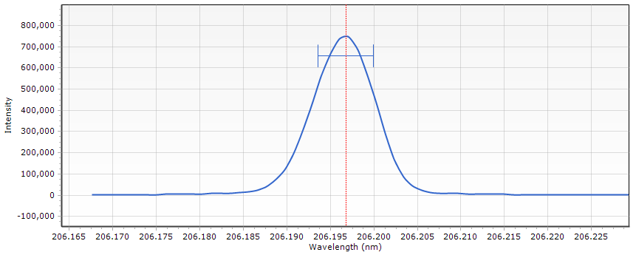
Figure 1. Cu 213.598 peak (top), and Zn 206.200 peak (bottom).
To demonstrate the capabilities and accuracy of ICP-OES, a 2008 penny was analyzed to determine its copper and zinc composition using an Agilent 5900 ICP-OES. In order to prepare the penny for analysis, a solution of 10 mL 50% HNO₃ and 10 mL 25% HCl was prepared, and the penny was placed in the solution and heated at 60 ºC until it was completely dissolved. Afterwards, the solution was diluted to an appropriate concentration for testing.
Figure 1 shows the ICP-OES results for the Cu 213.598 and Zn 206.200 spectral lines. These wavelengths were chosen due to a lack of spectral interferences and signal strength. Table 1 displays the measured concentration in ppm of each component of the analysis, as well as the comparison of the calculated percent composition to the actual percent composition of a 2008 penny¹.

Table 1 ICP-OES Analytical Results of a Dissolved 2008 Penny
Element | Concentration  (ppm) | Calculated  (wt %) | Theoretical  (wt %)
Copper | 0.7 | 2.5 | 2.5
Zinc | 26.2 | 97.5 | 97.5

The Agilent 5900 ICP-OES is equipped with a software called IntelliQuant analysis. Although less accurate than a standard ICP-OES test, an IntelliQuant analysis has the added benefits of producing concentration estimates quickly for multiple elements that are not calibrated for, and can be performed alongside a standard test. Table 2 shows IntelliQuant analysis results on the dissolved penny.

Table 2 IntelliQuant Analytical Results of a Dissolved 2008 Penny
Element | Concentration (ppm) | Calculated  (wt %) | Theoretical  (wt %)
Copper | 0.6 | 2.4 | 2.5
Zinc | 23.2 | 97.6 | 97.5

As illustrated through the 2008 penny analysis, ICP-OES can accurately determine the elemental composition of a sample. Additionally, this technique can accommodate materials with element concentrations magnitudes in difference. These facts make this technique ideal to quantify trace components as well as bulk constituents of a sample.
- U.S. Mint. https://www.usmint.gov/coins/coin-medal-programs/circulating-coins/penny (Accessed 25 April 2022).
To subscribe or unsubscribe to this newsletter, contact info@ebatco.com.

Ebatco, 10025 Valley View Road, Suite 150, Eden Prairie, MN 55344
+1 952 746 8086 | info@ebatco.com | www.ebatco.com

