Nano Brief

In hopes of making it easier to deliver drugs through the skin, MIT researchers have developed a wearable patch that applies painless ultrasonic waves to the skin, creating tiny channels that drugs can pass through. This approach could lend itself to delivery of treatments for a variety of skin conditions, and could also be adapted to deliver hormones, muscle relaxants, and other drugs, the researchers say.

https://onlinelibrary.wiley.com/doi/10.1002/adma.202300066
https://news.mit.edu/2023/wearable-patch-can-painlessly-deliver-drugs-through-skin-0419

NASA has demonstrated a breakthrough in 3D printable high-temperature materials that could lead to stronger, more durable parts for airplanes and spacecraft.

https://www.nature.com/articles/s41586-023-05893-0
https://www.nasa.gov/image-feature/nasas-new-3d-printed-superalloy-can-take-the-heat

Ebatco

As we continue to grow our business, we have hired on new talents to expand our expertise and testing lab service offerings. Please join us in welcoming the newest addition to the Ebatco team: Dr. Christopher Keller, Senior Analytical Chemist.

Dr. Keller received his B. S. degree in Polymer Science from the University of Southern Mississippi and his Ph. D. in Chemistry from Tulane University. During his undergraduate study, he participated in research on self-healing polymer films, drug delivery devices and surfactant phase diagrams. His doctoral work was focused on developing oil spill dispersants from polymer grafted nanoparticles and it has resulted in several peer-reviewed scientific publications. After receiving his Ph. D., he practiced chemistry first as an Assistant Brewer and later as a Chemist analyzing nutrition of food products before joining Ebatco.

As Senior Analytical Chemist at Ebatco, Dr. Keller is looking forward to further implementing methodologies for chemical, physical, and mechanical characterization of polymeric materials to better support customer needs.

Case Study

Determining the Flow Point of Shampoos using Rheometry
Household shampoos are designed with a desired point to flow under an appropriate level of stress. The amount of shear stress required to reach the point of flow, whether it be the force to squeeze the bottle of shampoo or simply the force of gravity, affects its feel and functionality. For instance, the flow point is essential to ensuring that the shampoo stored in a bottle pours out in a timely manner, and it does not run off your hand before you can apply it.

The Ebatco newly acquired MCR302e Rheometer (manufactured by Anton Paar) is an excellent choice for characterizing deformation and flow properties of a variety of fluids and viscoelastic solids including shampoos. MCR302e is capable of performing both rotational rheometry and oscillatory rheometry, using a wide range of shear stresses and shear rates in order to test viscoelastic behaviors of materials used in broad real-world applications. MCR302e with its heating and cooling stages can also allow explorations of the effects of temperatures on viscoelastic properties of materials from -150 °C to 400 °C.

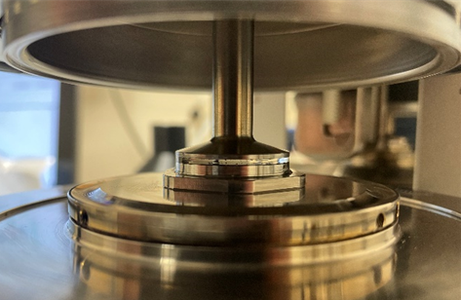
Figure 1. Parallel plate rheology measurement of shampoo.

In this study, two commercial shampoo samples were tested with a 25 mm parallel plate measuring configuration on the MCR302e (see Figure 1). The samples were placed between two parallel plates and subjected to a rotational shear stress. Viscosity was measured from the resulting torque at shear rates between 0.1 to 1000 s⁻¹.

From the testing results it is known that at low shear rates, the shampoo samples behave like a Newtonian liquid which has a constant viscosity. The constant viscosity at low shear rates could be used to determine the zero-shear viscosity. Shampoo 1 measured a higher zero-shear viscosity of 22.4 Pa·s whereas Shampoo 2 had a zero-shear viscosity of 15.1 Pa·s. This indicates that Shampoo 1 will require a greater force than Shampoo 2 to be filled into a bottle or to be applied to hair. Besides, if you were to simply pour Shampoo 1 in your hand and slowly tilt your hand, Shampoo 1 would take longer time to slide off your hand than Shampoo 2 would. This comment can be further explained through the flow point or yield point concept: shear stress required to cause a breakdown in the sample structure and to result in flow. As can be seen from the flow curves of the two shampoos shown in Figure 2 below, the yield point represents the transition between steady viscosities and rapidly decreasing viscosities when shear stress increases. The point at which these two segment slopes converge is the yield point (blue arrow in Figure 2). Shampoo 1 was found to have a yield point of 83.8 Pa, while Shampoo 2 had a yield point of 67.6 Pa. The higher yield point of shampoo 1 reaffirms that more force is required to cause Shampoo 1 to flow than it is required for Shampoo 2 to flow.

At higher shear rates, both shampoo samples exhibit shear thinning behaviors, where the viscosity decreases as the shear rate increases. At shear rates above 10 s⁻¹ (corresponding to approximately 100 Pa of shear stress) the viscosity of both shampoos appears to converge to very low values, which represents the regime where the shampoo is in a liquid state.

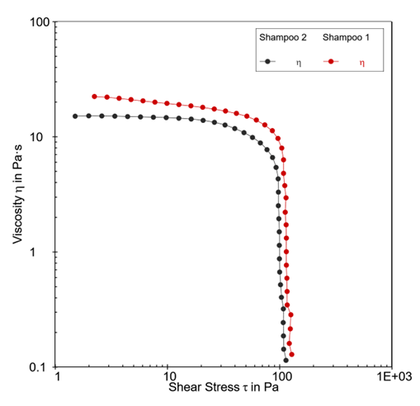
Figure 2. Flow curves of two shampoo samples. Blue arrow denotes the calculated yield point for each shampoo.

Obtaining viscosity flow curves are just the beginning of exploring the rheological properties of shampoos and other products. Rheometry studies can expand to help answer questions such as how the flow behavior of product changes with the addition of stabilizing additives or other formulation adjustments. Rheometry measurements could also capture a critical snapshot of a product’s properties under different storage environments or for different applications, through simulated timeframes and stressors, and thus save you both time and money that might have to be used to wait for field real-usage feedback.

To subscribe or unsubscribe to this newsletter, contact info@ebatco.com.

Ebatco, 10025 Valley View Road, Suite 150, Eden Prairie, MN 55344
+1 952 746 8086 | info@ebatco.com | www.ebatco.com

