

Nano Brief
“In thinking about nanotechnology today, what’s most important is understanding where it leads, what nanotechnology will look like after we reach the assembler breakthrough.”

“How we deal with atomically precise manufacturing will reframe the future for human life and global society.”

“Atomically precise manufacturing has implications for everything from medicine to economic development to climate change.”

“Atomically precise manufacturing (APM) could transform the material basis of human civilization.”
-K. Eric Drexler

Ebatco
A key component for particle Zeta potential and surface Zeta potential measurements is understanding the properties of the diluent liquid. Specifically, those properties are the refractive index, viscosity and dielectric constant. For a while, our NAT Lab was only able to characterize the refractive index and viscosity with a Rudolph J357 Refractometer and a Brookfield LV-II+ Pro Viscometer. For the dielectric constant, a reasonable value had to be selected based on the constitution of the diluent and known book values. This can be acceptable for simple solutions with a common liquid as the diluent, but not for solutions containing a mixture of different liquids. With the addition of a Brookhaven Instruments BI-870 Dielectric Constant Meter, we can now characterize all components of the diluent necessary for Zeta potential analysis with our Beckman Coulter DelsaNano C Particle Analyzer.

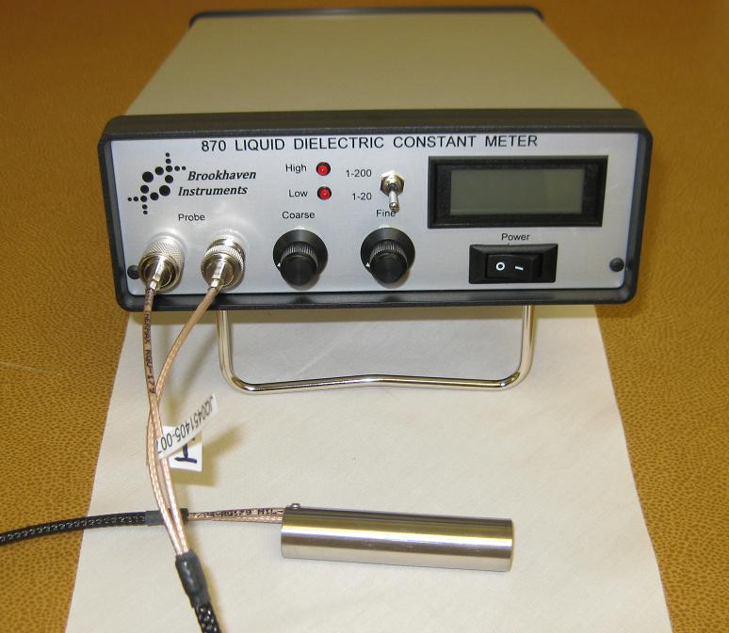
Brookhaven Instruments BI-870 Dielectric Constant Meter

Case Study
3D printing or additive manufacturing has been a hot topic in recent years. 3D printing or additive manufacturing is a layer by layer additive process of making three dimensional solid objects from a digital file using a 3D printer. There are several different ways for implementation of 3D printing, differing mainly in the way layers are built to create the final object. One of them is printing by depositing molten materials through an extrusion nozzle. This fascinating technique relies on materials’ ability to flow at moderate temperature and pressure, and a nozzle for extrusion the molten materials as tiny droplets to a substrate. The adhesion tendency between the molten material and the nozzle and between the molten materials and a previously printed layer or a substrate is critical to the success of material transferring. One way to characterize the adhesion tendency is to perform contact angle measurement between the molten material and the materials it will come in contact. In this case, the molten material needs to form a sessile drop on the nozzle, the substrate or the previously printed layer. Obviously, for this contact angle test a high temperature testing environment is required.

Ebatco’s NAT Lab has provided contact angle measurement services for numerous customers for many years. NAT Lab’s DM-701 Automatic Contact Angle Meter is equipped with high temperature accessories for measurements at elevated temperatures up to 380ºC. The figure below shows the DM-701 Automatic Contact Angle Meter with Heater Type Stage, Heater Type Dispenser and the Temperature Controller. Separate controllers control the Heater Type Stage and Heater Type Dispenser independently. The Heater Type Dispenser includes a special glass syringe that can use either a 22G or an 18G needle. The molten materials are dispensed at the set temperature with a micrometer head for a controlled volume. The solid sample is heated to the desired temperature using the Heater Type of Stage before the commencement of the contact angle measurement.

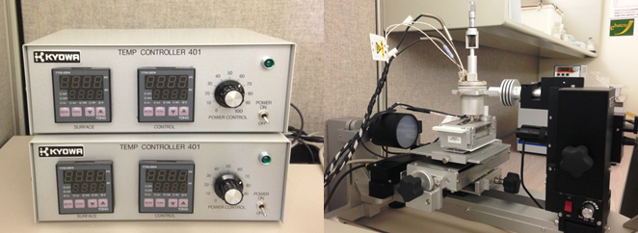
The DM701 Automatic Contact Angle Meter with Temperature Controllers (left) and Heater Type Dispenser and Heater Type Stage (right).

Polystyrene is one of the common materials for injection molding due to its fluidity, low shrinkage and good inherent thermal stability. High impact polystyrene (HIPS) has been used as 3D printing material. Thus, polystyrene has been selected for our case study of high temperature contact angle measurement. The figure below shows the optical images of molten polystyrene at high temperature on glass and stainless steel substrates for contact angle measurements. Before the droplet deposition, the substrate and the dispenser were heated to the set temperatures and allowed to equilibrate for a few minutes. The molten polymer was manually pushed through an 18G needle to form a pendant drop with volume approximately at 3.5 µL. Then the molten polymer was deposited and transferred onto the heated substrate. The images of the droplets were captured and recorded by a camera and the contact angles were analyzed through the analysis software. From the analysis results, it can be known that the molten polystyrene has a somewhat wetting on the substrates at elevated temperature. At 250ºC the contact angle of polystyrene with glass is 59.9º, and the contact angle of polystyrene with stainless steel is 45.3º.

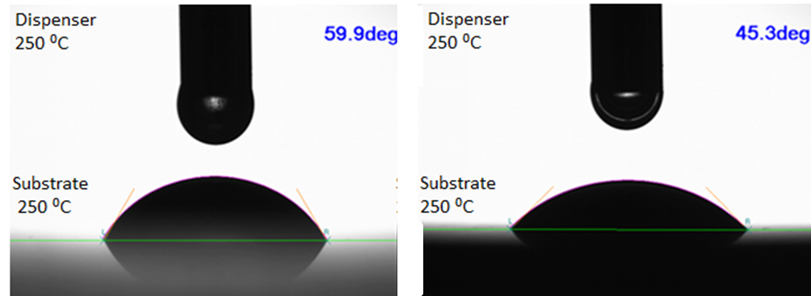
Molten polystyrene droplet on glass (left) and stainless steel (right).
To subscribe or unsubscribe to this newsletter, contact info@ebatco.com.

Ebatco, 7154 Shady Oak Road, Eden Prairie, MN 55344
+1 952 746 8086 | info@ebatco.com | www.ebatco.com

