

Nano Brief

We are excited to announce the grand opening of Ebatco Academy!

Ebatco Academy was created to disseminate scientific and technological knowledge and to provide essential and critical trainings in testing, measurement, and analysis using advanced instrumentation and techniques. The inaugural training session is scheduled on September 20th, 2018. The session will cover nanomechanical and chemical characterization of thin films and coatings and how to perform failure analysis. Please check out the attached brochure for further details, and please call us today to enroll!

Ebatco will be exhibiting at the following upcoming events:

- August 19th – 21st: American Chemical Society Meeting 2018, Boston Convention Center, Boston, MA

- September 11th – 12th, Coatings Trends and Technology, Loews Chicago O’Hare, Rosemont, IL

- October 15th – 17th: Materials Science and Technology 2018, Columbus Convention Center, Columbus, OH

- October 31st – November 1st, Medical Design & Manufacturing Minneapolis, Minneapolis, MN

- November 11th – 14th, National Association of Subrogation Professionals, Rosen Shingle Field Resort, Orlando, FL

Please stop by our booth to discuss the incredible world of nanomaterials, nanodevices, nanoinstruments, and nano/micro scale surface characterization with our staff scientists. We hope to see you there!

Ebatco
As we continue to grow our business we have hired on new talent to expand our marketing programs and testing lab services. Please join us in welcoming the newest addition to the Ebatco team: John Rosenow.

John Rosenow graduated from the University of Minnesota Twin-Cities with dual Bachelor’s degrees in Material Science/Engineering and Chemistry. His wide breadth of research experience spans areas from the mechanical testing and formulation of corrosion-resistant polymer coatings to the synthesis and spectral characterization of biologically active chemical compounds. Professionally, John enjoys focusing on analyzing the chemical and physical properties of materials and determining their suitability for different applications. John will leverage his academic and research experience to further support the Nano and Analytical Testing (NAT) laboratory by specializing in nano mechanical and surface/interface analysis techniques. The latest addition to the team at Ebatco, he looks forward to providing clients with timely, accurate, and meaningful results.

Case Study

Tensile Fracture Failure Mechanisms of 316L Stainless Steel

The strength of manufactured materials, especially metallic materials, is a critical parameter to measure prior to the product reaching the market. One method commonly used to test the strength of a material is tensile testing. Tensile testing is often vital to ensure user and product safety, prevent liability concerns, and avoid non-compliance issues. When metal devices fail during the test, however, it is critical to determine the root cause of the failure to generate not only a stronger product but a safer, more effective one. As such, this application note describes the tensile fracture analysis of a product composed of 316L stainless steel.

The 316L stainless steel sample was approximately 10.5 cm in length and had been tensile fractured approximately 4 cm from one of the ends (Figure 1). As can be observed from Figure 1, the cross-section of the fracture is uneven, and slight necking is observed at the fracture position.

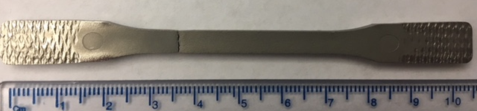
Figure 1. Image of the 316L stainless steel bar after tensile fracture.

To determine the failure mechanism, the fracture surface was initially analyzed via scanning electron microscopy (SEM). The SEM images at two different magnifications (250x and 1000x) of the center and the edge of the fracture are shown in Figure 2.

The SEM images in Figure 2 display a rough, dimpled morphology at both the edge and center surfaces, indicative of a ductile fracture. Particles were found at the base of these dimples, and the walls of these dimples had striped microstructures oriented perpendicular to the crack propagation front. Additionally, shear lips at approximately 45º angles were formed at the corners of the fracture. Based on these observations, the fracture was classified as a mixed-mode tensile fracture involving first a plain-strain fracture mode (mode I) and then a plane-stress fracture mode (mode II).

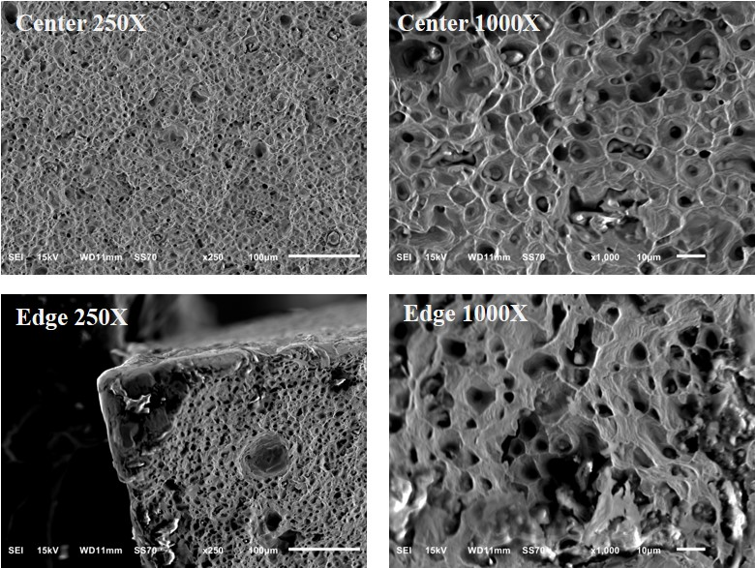
Figure 2. SEM images of the center of the fracture (top) and the edge of the fracture (bottom).

The first fracture mode initiated due to an increase in hydrostatic stress near the center of the sample. Microvoids then formed within the sample and coalesced to form cracks along the plane normal to the tensile load. Taken together, this is characteristic of a plane-strain fracture mode. This is further supported by the striped microstructures observed in the dimples, which suggest the presence of fibrous zones (Figure 2, right). As the propagation cracks approached the edge of the sample, 45º shear lips were formed, and the fracture mode changed from a plane-strain mode to a plane-stress mode (mode II).

To provide further insight, energy dispersive X-ray spectroscopy (EDS) was also performed on the fracture surface. Figure 3 shows the silicon and oxygen EDS maps on the fracture surface, and the images indicate the particles at the base of the dimples are SiO₂ inclusions. Originating from the stainless-steel manufacturing process, these SiO₂ inclusions must have been present in the initial austenite matrix. When the sample was stressed, the already-present voids near the inclusions grew to form dimpled microstructures around the SiO₂ inclusions. Based on the SEM/EDS analysis, the 316L stainless steel fracture mechanism was a combination of mixed fracture modes (mode I and II). Furthermore, the presence of SiO₂ in the austenite matrix facilitated the growth of microvoids, contributing to the cause of the fracture.

As observed, SEM/EDS analysis of fractures is a powerful method to determine failure mechanisms (and in this case contaminations) present in a failed product. This type of information not only aids manufacturers and developers to design safer, more effective products but also helps to avoid costly non-compliance and legal liability issues.

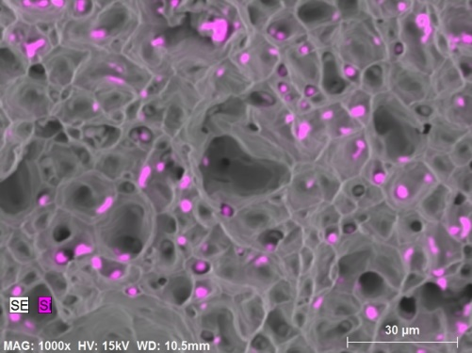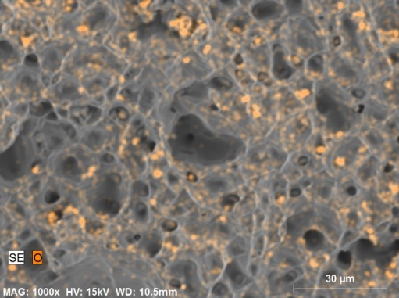
Figure 3. Si and O elemental maps of the 316L stainless steel fracture surface.

To subscribe or unsubscribe to this newsletter, contact info@ebatco.com.

Ebatco, 10025 Valley View Road, Suite 150, Eden Prairie, MN 55344
+1 952 746 8086 | info@ebatco.com | www.ebatco.com

