Nano Brief

In Nano News,

Scientists have developed a stretchable, breathable, lead-free perovskite/polymer nanofiber composite for hybrid triboelectric and piezoelectric energy harvesting. Essentially a fabric that can produce electricity from movement of the wearer. https://onlinelibrary.wiley.com/doi/10.1002/adma.202200042

Engineers at MIT and the Technical University of Munich have designed a new kind of glucose fuel cell that converts glucose directly into electricity. The device is smaller than other proposed glucose fuel cells, measuring just 400 nanometers thick, or about 1/100 the diameter of a human hair. The sugary power source generates about 43 microwatts per square centimeter of electricity, achieving the highest power density of any glucose fuel cell to date under ambient conditions. https://news.mit.edu/2022/glucose-fuel-cell-electricity-0512

When temperatures fall below freezing, cellphones need to be recharged frequently, and electric cars have shorter driving ranges. This is because their lithium-ion batteries’ anodes get sluggish, holding less charge and draining energy quickly. To improve electrical performance in the extreme cold, researchers reporting in ACS Central Science have replaced the traditional graphite anode in a lithium-ion battery with a bumpy carbon-based material, which maintains its rechargeable storage capacity down to -31 F. https://www.acs.org/content/acs/en/pressroom/presspacs/2022/acs-presspac-june-8-2022/lithium-ion-batteries-that-last-longer-in-extreme-cold.html

Ebatco

To celebrate 15 years of successful nanotechnology consulting and contract lab services, and to create a face-to-face meeting opportunity for friends, existing and potential customers, and nanotech enthusiasts, Ebatco will have an open house on Thursday, July 28th between 3pm and 8pm! Guided tours of our facility filled with many newly-acquired, state-of-the-art nanoscale analytical instruments, along with catered food, drinks, and fabulous door prizes will be offered to ensure a great time for all of our honored guests! For more information and directions, please see the attached announcement. We hope to see you soon!

Case Study

Fracture and Plastic Resistance of Automotive Paint Following ASTM D7187
Today’s automotive paints are engineered to possess a wide variety of characteristics, such as attractive color quality, a high gloss shine, and resistance to weather and abrasion. To have all of these traits, paints and coatings have had to continuously adapt their formulations and processing. ASTM D7187 is an international test standard for the evaluation of a coating’s scratch/mar resistance by measuring its fracture and plastic resistances. Fracture resistance is a measure of how much force must be applied to cause the coating to fracture or crack during a scratch test. This quantity is represented by a critical load value. Plastic resistance is a measure of how far the coating plastically deforms prior to fracture. This value is calculated by dividing the residual depth by the force at a given point. When different coatings are evaluated using the same testing conditions (using the same scratch speed, loading rate, temperature, humidity, etc.), fracture resistance and plastic resistance values can be used to rank the qualities of the coatings.
As a demonstration, Ebatco tested the paint on exterior panels from two domestic and two foreign consumer vehicle brands. The specimens were tested using a Nano-Scratch Tester made by Anton-Paar (Switzerland). The scratch tests were performed using a conical-spherical diamond indenter tip with a tip radius of 2 µm. To comply with the ASTM D7187 standard, the following testing parameters were used: scratch speed of 3 mm/min, loading rate of 40 mN/min, and contact force of 0.5 mN. All samples were conditioned at the appropriate temperature and humidity for at least 24 hours prior to testing. Scratch test data (left) and an optical image of the coating at point of fracture (right) from a typical measurement can be seen in Figure 1.

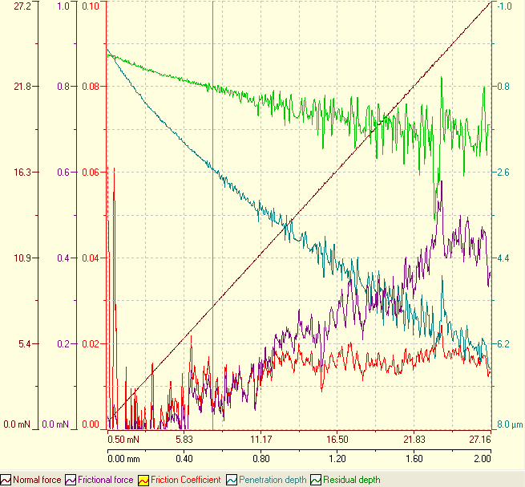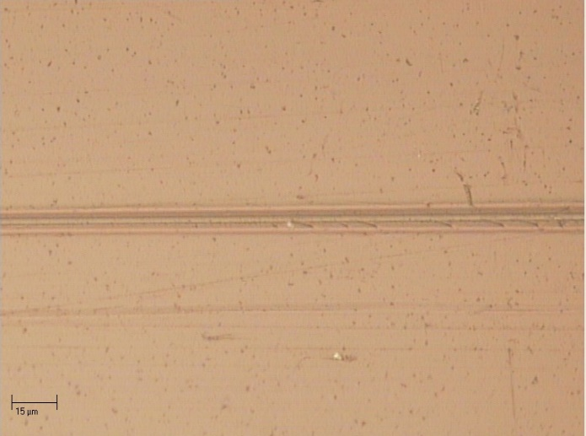

Figure 1. Scratch test data (left) and an optical image of coating fracture (right) on Domestic 2. The red arrow indicates the fracture initiation point.
All of the tested coatings exhibited similar scratch failure patterns. Along the scratch track, the coating was dug in by the scratch tip gradually, leaving a visible trench with increasing depths and widths behind until a certain point when cracks would begin to form. The cracks started out small, but would become larger and larger when the scratch load further increased. The tested coatings had average fracture resistance values ranging from 4.63 – 7.82 mN and average plastic resistance values ranging from 5.56 – 8.33 mN/µm. Figure 2 shows the average values of fracture resistance (left) and plastic resistance (right) for each paint panel. One coating, Foreign 2, had a significantly lower fracture resistance than the rest. Optical images of Foreign 2 suggest that the low fracture resistance may be caused by poor adhesion between the coating and the substrate. Foreign 1 had lower average plastic resistance value than the rest, indicating that this coating deforms the most under the same loading conditions.

These paint panel specimens were taken from used vehicles with varying ages and weathering histories. Frequent temperature swings, exposure to road dust and debris, and other environmental conditions may have caused these coatings to behave differently from when they were freshly applied. In fact, a common use for standardized scratch testing is to compare fresh paint samples with those subjected to accelerated aging or environmental conditions so as to determine a coating’s useful lifetime and their performances at different stages of its life cycle.

Figure 2. Average fracture resistance (left) and plastic resistance (right) for all tested vehicle panel specimens.

ASTM D7187 is a standardized testing method to determine paint coatings’ fracture resistance and plastic resistance. This type of testing can be used in paint coating quality control, formulation optimization, environmental impact evaluation, and long-term performance prediction when combined with accelerated aging of the paint coatings.

To subscribe or unsubscribe to this newsletter, contact info@ebatco.com.

Ebatco, 10025 Valley View Road, Suite 150, Eden Prairie, MN 55344
+1 952 746 8086 | info@ebatco.com | www.ebatco.com

