Nano Brief

The body is pretty good at healing itself, though more severe wounds can require bandages or stitches. But researchers publishing in ACS Applied Materials & Interfaces have developed a wound-healing ink that can actively encourage the body to heal by exposing the cut to immune-system vesicles. The ink can be spread into a cut of any shape using a 3D-printing pen, and in mice, the technology nearly completely repaired wounds in just 12 days.
https://www.acs.org/pressroom/presspacs/2023/june/painting-wound-healing-ink-into-cuts-with-3d-printing-pen.html
https://pubs.acs.org/doi/abs/10.1021/acsami.3c03630

A new ‘smart surface’ has been shown to successfully remove unwanted sulfur aromas from wine, opening up new opportunities for Australian winemakers. Developed by scientists from Australian Wine Research Institute (AWRI) and Flinders University, the technology is based on applying a thin plasma polymer coating to a surface and then immobilising nanoparticles on that surface, which then bind strongly to sulfur compounds in wine.
https://news.flinders.edu.au/blog/2023/05/16/nano-tech-for-better-wine/
https://www.nature.com/articles/s41538-023-00180-8

Ebatco

After a long hiatus due to the pandemic, Ebatco happily welcomes the opportunities to meet with you again at industrial conferences and exhibits:

- Aug. 13th – 17th, American Chemical Society 2023, Booth# 1156, Moscone Center, San Francisco, CA
- Oct. 10th – 11th, MD&M Minneapolis, Booth# 2838, Minneapolis Convention Center, Minneapolis, MN
- Oct. 16th – 19th, IMAT 2023, Booth# 1926, Huntington Place, Detroit, MI
If you are attending any of these events, please come and visit us to discuss how Ebatco could support you on your unmet analytical and testing needs!

Case Study

Friction Between Simulated Finger Skin and Device Screens
The screen on a smartphone is one of the most important interfaces between a phone and its user. The user often has to touch the screen to unlock the phone first, and then touch the specific function icon the user would like to use. How a touchscreen is felt during the interactions between its user and an electronic device determines both the perceived and actual comfort of use, which can be an important factor influencing decision when a consumer buys an electronic device. The sticky or sleek feeling of the finger on an electronic device screen can be tested and quantified by friction measurement. By definition, friction represents a surface’s resistance to relative motion against another surface. When two surfaces rub against each other, friction acts as the force that prevents the two surfaces from moving apart.

In this application note, friction coefficients between a flat silicone rubber block, simulating a piece of finger skin, and two commercial smart phone screens with or without screen protectors at different levels of cleanliness, and also a glass slide were measured at room temperature under lab ambient conditions. Figures 1 and 2 show the friction coefficients of the smart phone screens and screen protectors sliding against the silicone rubber block, as a function of sliding distance. Figure 3 presents average static and kinetic friction coefficients for all samples tested.

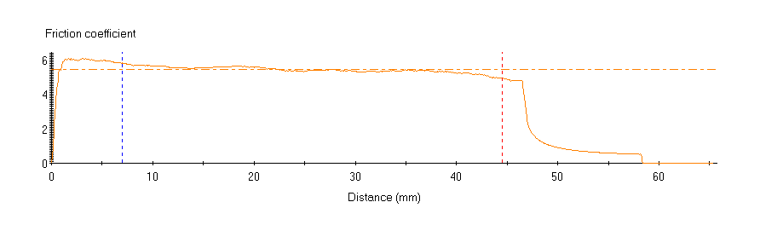
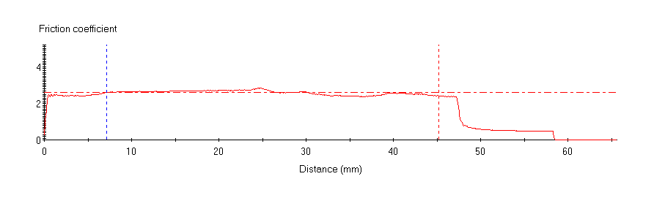
Figure 1. Friction coefficients of Phone 1 with the screen uncleaned (top) and cleaned (bottom) sliding against a silicone rubber block simulating finger skin.

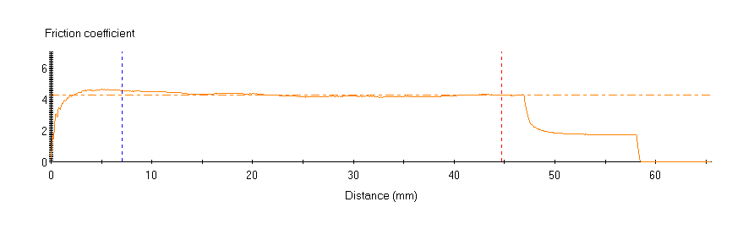
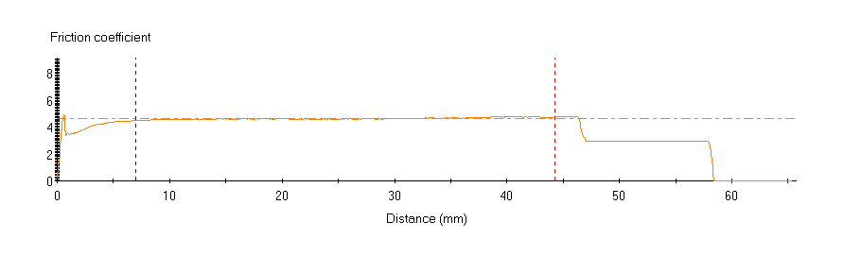
Figure 2. Friction coefficients of Phone 2 with a screen protector uncleaned (top) and cleaned (bottom) sliding against a silicone rubber block simulating finger skin.

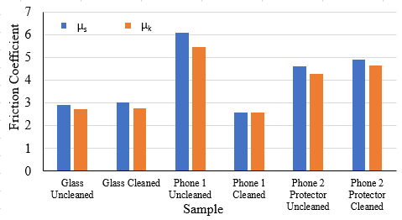
Figure 3. Average static and kinetic coefficients of friction for each sample sliding against a silicone rubber block simulating finger skin.

As can be seen from Figures 1 - 3, static friction coefficients (µ_{s}) are higher than kinetic friction coefficients (µ_{k}) as they should be. Cleaning did not change the friction coefficients much for both Glass Slide sample and Phone 2 with a screen protector, most likely because their surfaces were not that dirty to begin with. However, cleaning did change the friction coefficients of Phone 1 screen dramatically. Clearly, the touch screens of electronics would need to have desired sleek/friction specifications in order to maximize users’ experience. Friction measurements can be useful to aid the designers to measure and fine tune the touch screen surface properties.

To subscribe or unsubscribe to this newsletter, contact info@ebatco.com.

Ebatco, 10025 Valley View Road, Suite 150, Eden Prairie, MN 55344
+1 952 746 8086 | info@ebatco.com | www.ebatco.com

