

Nano Brief
We have signed up to attend the NIP 30 and MN AVS Annual Symposium conferences. For NIP 30 in Philadelphia, PA, we will be representing Kyowa Interface Science. The following is the updated list for our remaining events for the year:

- September 7th-11th, Non-Impact Printing 30 Conference & Exhibition, Sheraton Philadelphia Downtown Hotel, Philadelphia, PA *representing Kyowa Interface Science, Co. Ltd.
- September 18th, MN AVS Annual Symposium, CEC Center, University of Minnesota, St. Paul, MN
- October 12th – 16th, Booth #319, Materials Science & Technology 2014, David L. Lawrence Convention Center, Pittsburgh, PA
- November 3rd – 9th, Booth #607, International Symposium for Testing and Failure Analysis, Houston, TX

Please stop by our booth to discuss the incredible nano world of nanomaterials, nanodevices, nanoinstruments, and nano/micro scale surface characterization with our staff scientists. We hope to see you there!

Ebatco
For anyone who happens to be around the Twin Cities metro area, Ebatco is now offering a facility tour and demonstration. The activities include a presentation followed by a facility tour and concluding with a technical discussion and instrument demonstration. Two-hour blocks have been set aside for each session throughout the day. These sessions are available yearlong Monday though Friday. Topics for discussion and demonstration include:

• Chemical • Particle Size
• Contact Angle • Pore Size
• Liquids • Thermal
• Mechanical • Tribologiccal
• Metallurgy • Zeta Potential
• Microscopy

Visit our website, www.ebatco.com, for contact information to sign up for a tour at your convenience.

Case Study
Metallography is the study of the physical structure and components of metals. The properties of metals are controlled by both microstructure and chemical composition. For example, different microstructures could occur depending on the heat treatment or solidification process with the same chemical compositions for a steel sample. With the proper cutting, polishing and etching process, the intrinsic microstructure of a metal can be revealed through optical microscopy. By analyzing its microstructure, both naturally occurring and those resulting from engineering processes, a metallographic study can identify the metallurgical characterization of a material such as grain size, porosity and voids, phase separation, crack and inclusions. Metallography is one of the primary tools to analyze metal failure mechanisms such as fatigue, corrosion, creep, stress ruptures, fractures, cracking and hydrogen embrittlement.

The Nano Analysis Lab in Ebatco’s facility provides a comprehensive metallography analysis services. Our instruments include various optical instruments such as a Zeiss Axioscope and AmScope Stereo Microscope, and a state-of-the-art low vacuum scanning electron microscope (SEM). This SEM is a JEOL JSM-6610LV SEM and is equipped with a Bruker QUANTAX 200 Energy Dispersive X-ray Spectroscopy (EDS). The EDS system can further assist in identifying and quantifying the chemical compositions of the areas of interest by measuring the characteristic X-rays produced by atoms that are present on the surface.

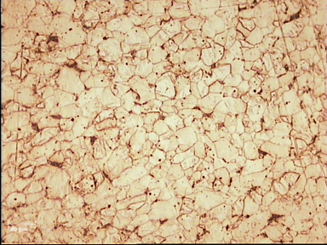
Microstructure of Low-Carbon Steel

The above figure shows the dark pearlite patches distributed through the matrix of ferrite grains of a low-carbon steel surface. The amount of pearlite increases with the increase in carbon content and reaches up to a maximum of 100% at carbon content near 0.8%. Low-carbon steel is the most common form of steel because of its relatively low price and acceptable materials properties. It is often used as structural steel in large quantities.

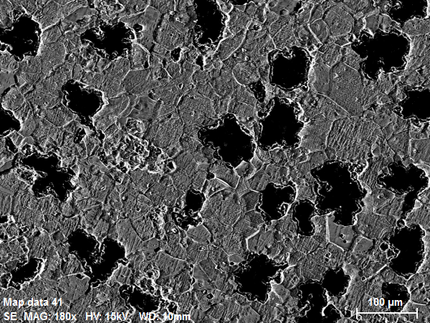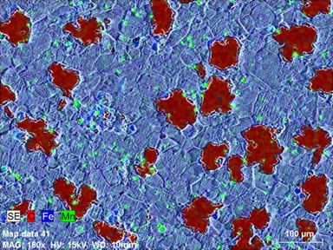
Microstructure of malleable cast iron, SEM image (left) and EDS image (right).

The above figure shows the small, roughly spherical aggregates of graphite among the ferrite grain matrix of a malleable cast iron surface. The EDS elemental analysis showed that manganese was distributed as the main additive for iron to neutralize sulfur and to improve hardness and strength. Malleable cast iron has been used as early as the 4th century BC. During heat treatment, the carbide decomposes into graphite. Due to the absence of the hard and brittle carbide constituent, the iron became malleable. Malleable cast iron can be used for small castings requiring good tensile strength and ductility such as electrical fittings, hand tools and pipe fittings.

To subscribe or unsubscribe to this newsletter, contact info@ebatco.com.

Ebatco, 7154 Shady Oak Road, Eden Prairie, MN 55344
+1 952 746 8086 | info@ebatco.com | www.ebatco.com

