

Nano Brief
A big thank you to all of those who were able to attend our second open house! We hope everyone had a good time and were able to enjoy all the festivities. Congratulations to all the raffle winners, we hope you have enjoyed your prizes!

With better understanding on who we are and what we do, if you think we can assist you in any way through our product and lab service offerings we would be very happy to support you. Please feel free to contact us at any time!

Ebatco
The latest addition to our NAT Lab is the Kyowa Versatile Peel Analyzer VPA-2. The VPA-2 is an ideal tool in the world of pressure sensitive adhesives. With this instrument, the peel strength of an adhesive tape can be characterized according to peel speed and peel angle. The VPA-2 can reach a maximum peel speed of 30,000 mm/min and can be set to measure peel strength at any angle between 0° and 180°. These characteristics allow the VPA-2 to simulate a wide range of real world situations where a peel separation is of interests. The VPA-2 also features a heater type of stage that is capable of reaching temperatures up to 180°C. With the heater type of stage, the VPA-2 can not only characterize peel strength at a variety of peel speeds and peel angles; it can also evaluate the influence of temperature on the peel strength and adhesion. Come visit our lab to see the instrument in action or call us for a discussion on your possible applications of this versatile peel strength analyzer!

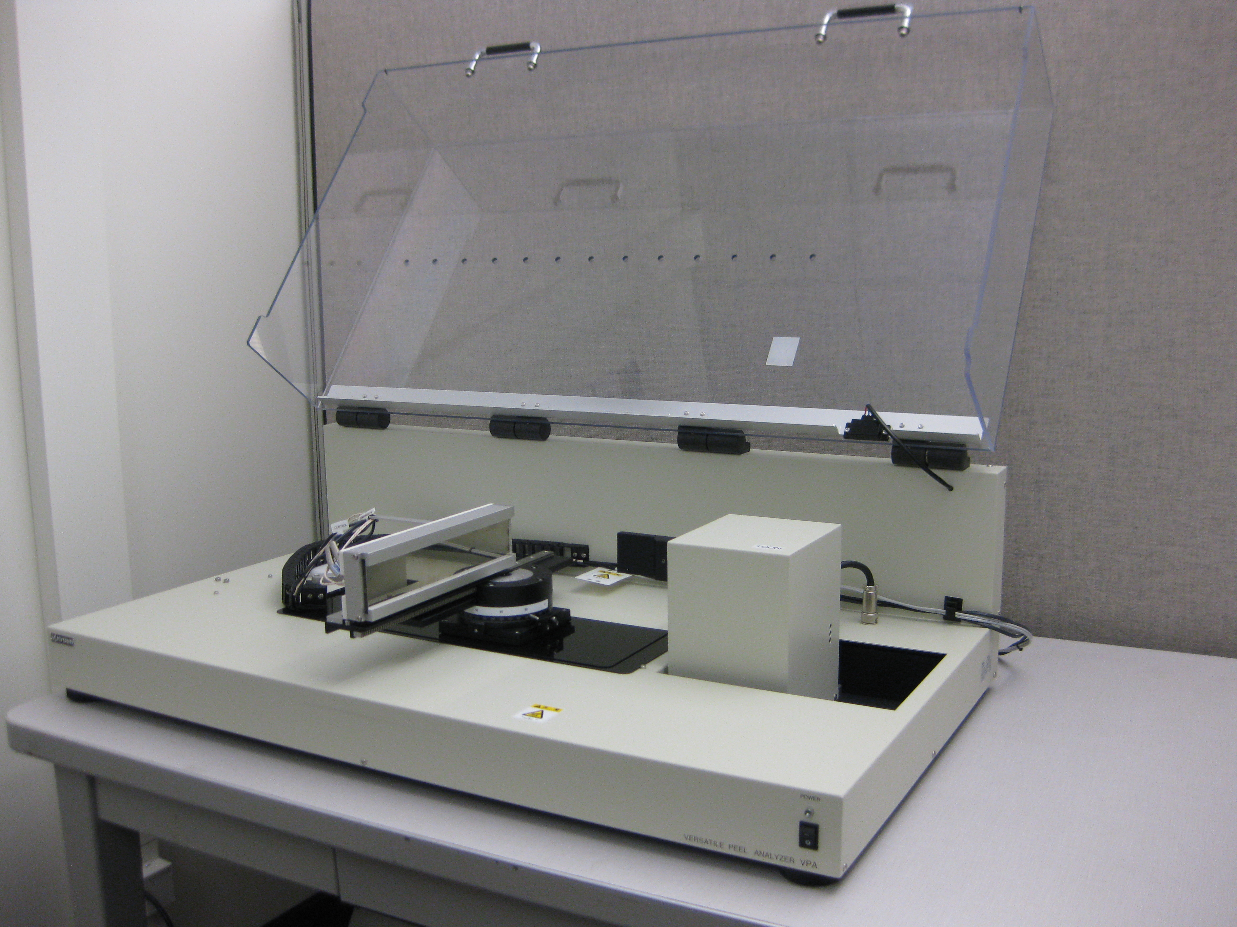
The Kyowa VPA-2 Versatile Peel Analyzer with Heater Stage

Case Study
Understanding the thermal behavior of a material can be very useful to manufacturers who melt metals and alloys such as in casting parts or soldering electronic components. Knowing the melting temperature and latent heat of fusion can help to prevent overheating the molten metal unnecessarily and reduce energy costs. It can also help to prevent other issues caused by overheating a melt including increased oxidation, melt container corrosion, and mass loss through evaporation. In soldering electronics applications, it can help to eliminate possible damage to critical components due to overheating.
Differential scanning calorimetry (DSC) is an analysis technique that is widely used to analyze the thermal behavior of a material. DSC can be used to determine phase transition temperatures, the enthalpy of such transitions, and reaction kinetics. It is an indispensable tool for determining melting temperature and latent heat of fusion.

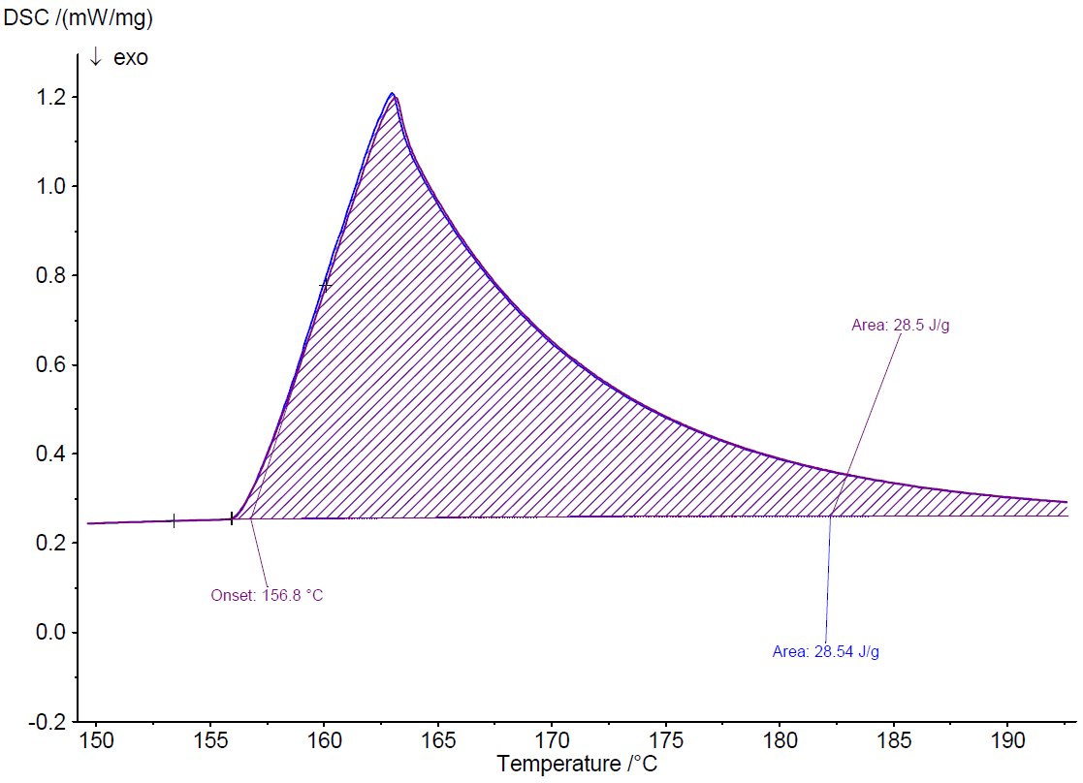
DSC curves of two test runs for the melting of indium.
Indium metal is commonly used in lead-free solder applications. In reflow soldering, the entire printed circuit board is subjected to temperatures slightly above the solder’s melting temperature. Understanding the thermal behavior of indium-rich solder in such applications can be crucial to fine-tuning the process in order to reduce processing time and cost.
The above figure presents two overlapping DSC data curves obtained in two test runs for melting indium. The tests were performed on an Ebatco NAT Lab’s Simultaneous DSC/TGA Apparatus STA 449 F3 Jupiter manufactured by Netszch (Germany). The average melting temperature for the indium sample was measured as 156.8ºC. The sample’s latent heat of fusion was measured as 28.52 kJ/kg.
To subscribe or unsubscribe to this newsletter, contact info@ebatco.com.

Ebatco, 7154 Shady Oak Road, Eden Prairie, MN 55344
+1 844 3Ebatco (844-332-2826) | info@ebatco.com | www.ebatco.com

