

Nano Brief
We have signed up to attend the MN AVS Annual Symposium, BioInterface Workshop and Symposium, and MS&T. The following has more information for the remaining events of the year:

- October 3rd-5th, BioInterface Workshop and Symposium, The Commons Hotel, Minneapolis, MN; exhibition booth
- October 11th, MN AVS Annual Symposium, CEC Center, University of Minnesota, St. Paul, MN; exhibition booth
- October 23rd-27th, Materials Science & Technology 2016, Salt Palace Convention Center, Salt Lake City, UT, attendance only, no exhibition booth

Please stop by our booth or meet with our staff scientists to discuss the incredible nano world of nanomaterials, nanodevices, nanoinstruments, and nano/micro scale surface characterization. We hope to see you there!

Ebatco
You can connect with us via traditional ways: in person, by phone, fax, email or through our website, LinkedIn, Facebook, YouTube, Google+, or Twitter. Ebatco has just created a Twitter account. Please follow us @Ebatco for the latest updates on nanotechnology and Ebatco!

Case Study
There are many ways to examine the fine details of a surface. A common method is surface roughness analysis. Surface roughness characterizes surface features at micro and nanoscale in very well defined quantities.

Surface roughness can be measured by contact or non-contact methods. Non-contact methods are based on 3D optical profilers. Methods of optical profiling include phase-shift interferometry (PSI), using a single wavelength of light to measure features in the nanometer range. Another method, vertical-scanning interferometry (VSI), uses multiple wavelengths of light or white light to measure features from nanometer to millimeter range. The figure below shows a coated wafer specimen surface analyzed using phase-shift interferometry (PSI).

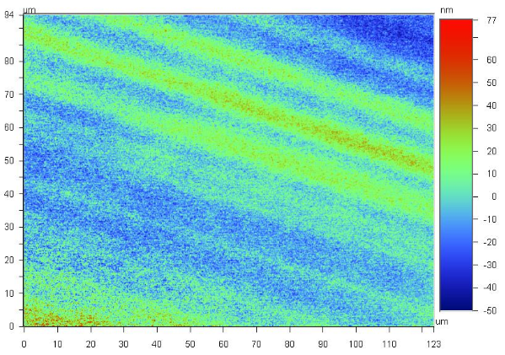
Surface topography of a coated wafer after tilt correction; striations of films with varying thickness can be clearly seen.

Among the many surface roughness parameters used to characterize surfaces, the most common ones include, but are not limited to, R_{a}, R_{q}, R_{z}, and R_{t}. R_{a} is the Average Roughness. It is the arithmetic average of the absolute values of the profile height deviations from the mean line, recorded within the evaluation length. R_{q}, or R_{RMS}, is the Root Mean Square Roughness. It is the root mean square average of the profile height deviations from the mean line, recorded within the evaluation length. R_{t} is the Maximum Height of the Profile. It is the maximum peak-to-valley height, found over the entire measured range. R_{z} is the Average Maximum Height of the Profile or Ten-Point Mean Roughness. It is the average of the vertical distance from each of the five highest peaks to its lowest adjacent valley within the profile.

Presented here are two surface roughness analyses conducted using a Wyko NT3300 Optical 3D Profiling System. The figure above is the surface topography of the surface of a wafer coating and the figure below is the surface topography obtained on an area of a pair of stainless steel scissors. Due to the fact that the coated wafer surface is smooth, phase shift interferometry technique was used for its nanometer precision. For the stainless steel scissors surface, vertical-scanning interferometry was selected for its appropriate measurement range. Surface roughness results of R_{a}, R_{q}, R_{z}, and R_{t} are listed in the table. From the table it can be seen that the coated wafer is significantly smoother than the scissors surface although their surfaces are each suitable for their designed purposes.

Surface Roughness Measurement Results
Test | Ra (nm) | Rq (nm) | Rz (nm) | Rt (nm)
Wafer | 9.98 | 12.58 | 115.01 | 127.51
Scissors | 290.70 | 371.53 | 3711.76 | 5004.39

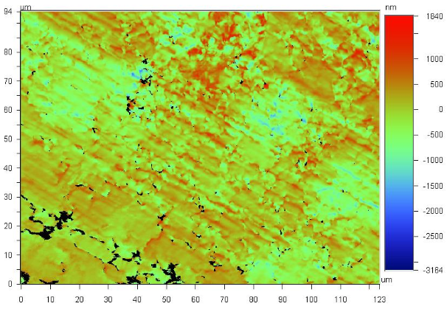
Surface topography of an area on a pair of scissors with tilt correction.

To subscribe or unsubscribe to this newsletter, contact info@ebatco.com.

Ebatco, 7154 Shady Oak Road, Eden Prairie, MN 55344
+1 952 746 8086 | info@ebatco.com | www.ebatco.com

