

Nano Brief
This past week marked Ebatco’s completion of the assessment for the ISO/IEC 17025:2005 accreditation. The scope of Ebatco’s ISO/IEC 17025:2005 accreditation spans from mechanical, chemical to thermodynamic testing. We are very keen to finish the required procedures and to receive the accreditation. This will be another milestone that Ebatco has proudly achieved. We are sure that our clients will be very happy to know about it and we will inform you as soon as we receive the accreditation. Please visit us at www.ebatco.com often to check the status of it, or look for it in the next newsletter!

Ebatco
As we continue to grow our business we have hired on new talents to expand our marketing programs and testing lab services. Please join us to welcome our two new additions to our technical team: Mr. James Schroder and Mr. Hayden Baker.

Mr. James Schroder graduated in Spring 2017 from the University of Wisconsin-Stout with a Materials and Nanoscience Major and a Chemistry Minor. His undergraduate research included using spatial light modulation to create an optical vortex by manipulating the orbital angular momentum of the light. He also researched manufacturing of metals using a femtosecond pulsed laser for an internship at Iowa State University. He is excited to apply his knowledge of nanoscience to the industrial applications that Ebatco offers.

Mr. Hayden Baker graduated in the Spring of 2015 from Winona State University with a Bachelor of Science degree in Composite Material Engineering. He worked on a team that designed a solar powered thermoelectric cooler. He is interested in bringing composites materials into different industries and improving the quality of products through testing and characterization of the products at nano and micro scales.

Case Study
Among the many capabilities of the NAT Lab’s Netzsch STA 449 F3 Jupiter, is the ability to determine the degree of curing for a thermoset polymer resin such as an Epoxy. Further understanding the extent of curing in the polymer system can help to ascertain the performance and reliability of the material and to identify the ideal timing for use. With poor crosslinking, epoxies risk failing to meet specifications which can lead to disastrous results for customers relying on their adhesive strength. Differential Scanning Calorimetry (DSC) operates by comparing heat flow through a sample to that of a reference. Heat absorbed or released by the sample during a transition will generate an offset correlating to the enthalpy of reaction. In the presence of a dedicated curing agent, epoxy resins will undergo such a transition where crosslinked bonds begin to form and an exothermic peak is observed in the plot of heat flow vs time.

For this experiment, epoxy was mixed using a provided corkscrew applicator tip and deposited into aluminum crucibles in preparation for analysis. Samples were allowed to cure for 7 min, 20 min, 1 hr, and 24 hr intervals prior to testing. One uncured sample (tested at < 5 min prior to the product’s reported onset of curing) and one fully cured sample (heated once to 250 ºC to accelerate curing, and cooled back down to room temperature prior to testing) were also included in order to demonstrate the complete thermal behavior of the epoxy before and after curing.

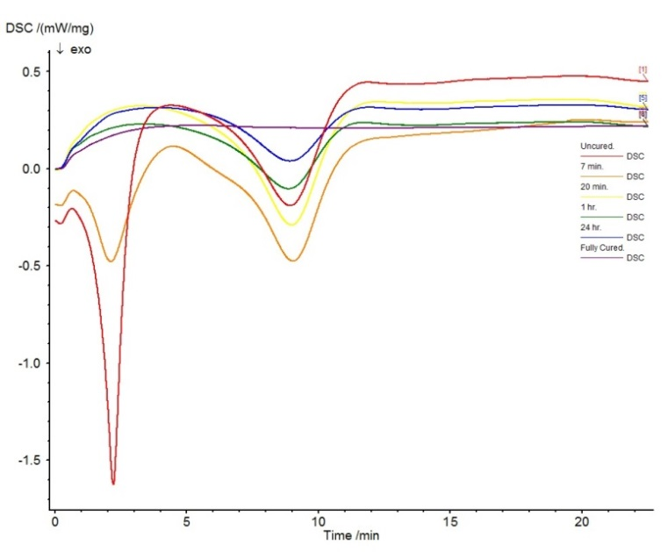
Figure 1. Exothermic peaks of epoxy curing for various time intervals.

Exotherms depicting the heat flow with respect to temperature (time) were observed and the areas under the curves were used to calculate the enthalpies of transitions. Testing the uncured epoxy revealed distinct thermal peaks occurring at 43.8 ºC and 114.4 ºC. Using the instrument software to integrate the areas under the curve, the total enthalpy of curing was determined to be 189.79 J/g. Enthalpies were obtained for each of the curing times and compared with the total to determine a relative percent of cure (see Table 1).

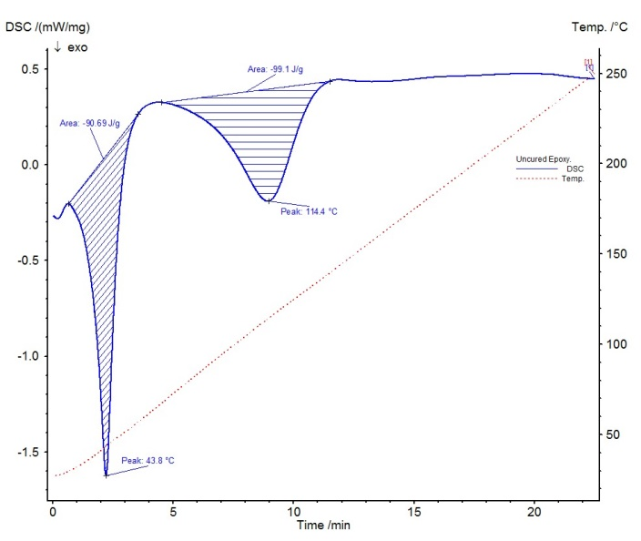
Figure 2. Areas under the peaks of the uncured sample showing enthalpy of the full reaction.
Table 1 Enthalpies of Reaction and Associated Percentages of Curing for Epoxy Resins
Sample | Enthalpy | Degree of Cure
Uncured | 189.79 J/g | 00.0 %
Cured for 7 min | 144.53 J/g | 23.8 %
Cured for 20 min | 108.60 J/g | 42.8 %
Cured for 1 hr | 62.33 J/g | 67.2 %
Cured for 24 hr | 48.52 J/g | 74.4 %
Fully Cured | 0.00 J/g | 100.0 %

By comparing the percentages of curing, it can be known that approximately 42.8% of the cure has occurred by the 20 minute mark at which time the product label claims the epoxy is ready for use, and only 74.4% cure has occurred at the 24 hour mark when the product is said to be “fully cured.” This observation is consistent with expected degrees of curing for two part room temperature cured epoxy that typically rely on longer time or heating to achieve a complete cure.

To subscribe or unsubscribe to this newsletter, contact info@ebatco.com.

Ebatco, 7154 Shady Oak Road, Eden Prairie, MN 55344
+1 952 746 8086 | info@ebatco.com | www.ebatco.com

