

Nano Brief

We are excited to see those of you who have registered or expressed interest in attending the Ebatco Academy training course scheduled for September 20th, 2018 on Characterization and Failure Analysis of Thin Films and Coatings. There are still a few seats available if you have not registered. Please contact us soon to reserve your seat!

Additionally, Ebatco will be exhibiting at these upcoming events:

- September 11th – 12th, Coatings Trends and Technology, Loews Chicago O’Hare, Rosemont, IL

- October 15th – 17th: Materials Science and Technology 2018, Columbus Convention Center, Columbus, OH

- October 21st – 23rd: American Chemical Society Midwest Regional Meeting, Iowa State University, Ames, IA

- October 31st – November 1st, Medical Design & Manufacturing Minneapolis, Minneapolis, MN

- November 11th – 14th, National Association of Subrogation Professionals, Rosen Shingle Field Resort, Orlando, FL

Please stop by our booth to discuss the incredible world of nanomaterials, nanodevices, nanoinstruments, and nano/micro scale surface characterization with our staff scientists. We hope to see you there!

Ebatco

We would like to congratulate Dr. Dehua Yang for his induction as an ASM International Fellow! Fellows are selected by their colleagues based on the nominee’s extraordinary contributions to the material science and engineering fields. Dr. Yang was selected “for distinct and significant impacts on cutting edge nanotechnology applications, including nano-scale materials testing and characterization”.

As a part of our ongoing commitment to provide you with robust and meaningful analytical results, Ebatco is committed to maintaining its ISO 17025 accreditation. Scheduled on August 31st, Perry Johnson Laboratories Accreditation, Inc. will be conducting its annual audit to ensure our operations and methods are compliant with the stringent ISO 17025 standards.

Case Study

Infrared/Raman/AFM Tri-modal Imaging

Multimodal imaging techniques are critical to perform synergistic data acquisition methods. The WITec 300RA Confocal Raman/AFM Microscope is a great illustration of multimodal imaging systems because with a simple rotation of the microscope turret, confocal optical, Raman and AFM imaging can be performed. Furthermore, due to the ease of sample transfer between Ebatco’s Cary Agilent 670 FTIR Microscope, tri-modal imaging can be regularly practiced with little-to-no sample contamination or perturbation. In this application note, a polymer laminate was placed in an FTIR microvice holder and characterized using FTIR spectroscopy first. The microvice sample holder was then lifted in its entirety (without disturbing the sample) and placed under the 20x objective of the confocal Raman/AFM microscope, where the sample was sequentially characterized via Raman and AFM.

In Figure 1, three overlays are provided to illustrate how the confocal Raman-AFM multiple function microscope and FTIR microscope can be used to very easily image a plastic laminate. Because each technique is responsive to different stimuli, unique information is extracted from each type of analysis.

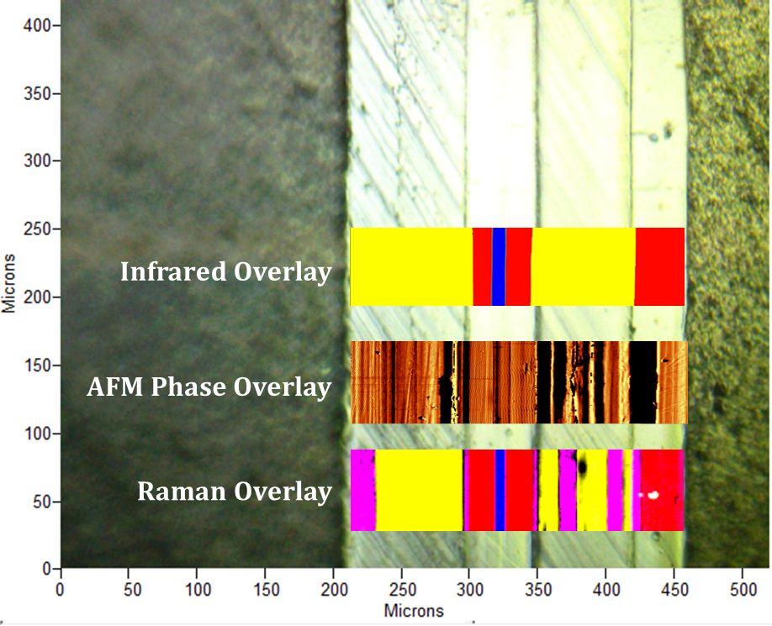
Figure 1. An optical image of a multilayer laminate cross-section taken using the 4x FTIR objective overlaid with an infrared image, an AFM phase image, and a Raman image.

From the top of the image down, the IR overlay is shown first. IR imaging is sensitive to chemical bonds present in each layer, and as such three unique polymers were identified (represented by three colors). The three polymers were found to be layered in such a way to create a six-layered cross-section.

In comparison to IR imaging, AFM phase imaging is not only sensitive to chemical structures, but also other physical and mechanical properties such as elasticity, viscosity, adhesion, and friction. Changes in these surface properties of a polymer can be a result of chemical modification, polymer orientation, or polymer crystallinity, to name a few, all of which affect the resulting contrast in an AFM phase image. Because of this wide variety of effectors, one can isolate over fifteen distinct layers in the AFM image. As observed, changes in surface properties do not necessarily result in spectroscopic changes in the IR overlay.

Finally, Raman imaging is sensitive to chemical bonds present in the sample. However, the selection rules for chemical bonds that can undergo Raman scattering are different than those that can undergo IR excitation. As such, different bands are present in the Raman spectra than are present in the IR spectra even though the polymers present are identical. Furthermore, the Raman scattering linewidths are markedly smaller than corresponding infrared linewidths, resulting in a more resolved spectrum. It is because of the more resolved Raman spectrum that more information can be obtained. The Raman image in Figure 1 clearly shows at least fourteen bands that are reflective of different chemical bonds, molecular orientations or degrees of crystallinity present in the polymers of the plastic laminate.

Some correlation is certainly observed between the AFM and Raman overlays, indicating the changes in surface properties of the polymers result from the crystallinity or amorphous morphology of the polymer. However, there is also some discrepancy between the images, suggesting that there are other Raman-insensitive factors at play. The AFM bands that do not have corresponding Raman bands could be explained by changes in other surface properties.

As illustrated, with the current instrument suite and setup at Ebatco, samples can be easily transferred between the two imaging microscopes with minimal interruption to perform Infrared/Raman/AFM tri-modal imaging. The multimodal imaging approach helps correlate changes in surface properties to changes in polymer chemical structure, crystallinity and orientation.

To subscribe or unsubscribe to this newsletter, contact info@ebatco.com.

Ebatco, 10025 Valley View Road, Suite 150, Eden Prairie, MN 55344
+1 952 746 8086 | info@ebatco.com | www.ebatco.com

