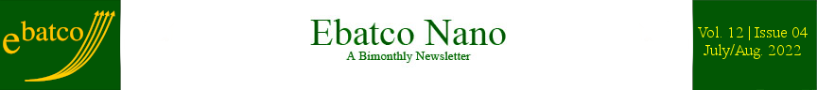

Nano Brief

The CHIPS and Science Act of 2022 was passed by Congress and signed into law recently which will attempt to make the United States more competitive in semiconductor manufacturing. The bill will provide $52 billion for companies to manufacture computing chips and billions more in tax credits and research funding. Nanotechnology is a key component of chip manufacturing. As a nanotechnology development and service provider, Ebatco stands ready to provide assistance in R&D and quality control for our customers in the semiconductor industry! https://www.cnbc.com/2022/08/02/biden-signs-china-competition-bill-to-boost-us-chip-production.html.

Currently, most lithium and sodium batteries contain flammable electrolytes, but – in a paper published in the prestigious Nature Materials journal – researchers from UQ’s Australian Institute for Bioengineering and Nanotechnology (AIBN) and Deakin’s Institute for Frontier Materials found the safety and life-cycle of sodium batteries improved when these traditional solvents were swapped out. https://aibn.uq.edu.au/article/2022/07/power-play-new-electrolyte-means-faster-more-reliable-batteries.

Ebatco

Thank you to everyone who came to our open house to celebrate Ebatco’s 15 years of nanotech consulting and lab services with us on July 28th! It was so nice seeing new and familiar faces and having great time together. We hope that you have enjoyed the gatherings and the lab tours!

Among many happy and exciting events and memories as exampled in the below pictures, the Open House had reached its excitement apex around 7pm when the door prize drawings were carried out. Against all odds, one guest surprisingly drew his own ticket number and won the Twins baseball tickets! Congratulations once again to the all lucky door prize winners!

What an event to mark the 15th Anniversary of Ebatco! Thank you and hope to see you again soon!

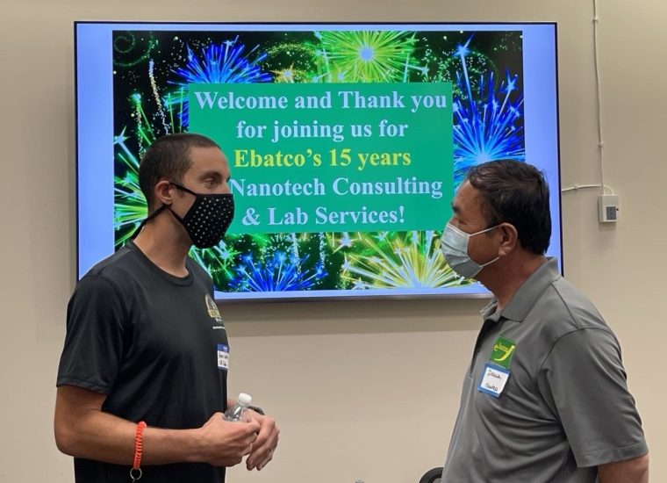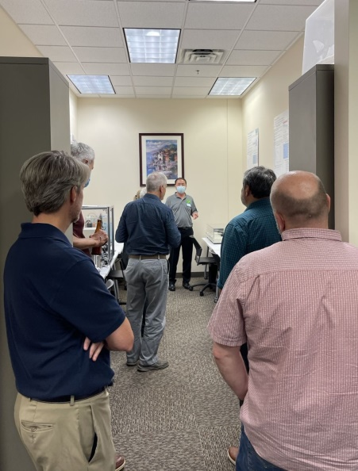
Peter Goldberg (left, guest) meeting with Dehua Yang (right, Ebatco). Lab tour in action.


“The Hysitron Reunion”: Thomas Wyrobek (left, guest) and Dehua Yang (right, Ebatco).

To support customers’ needs on particle counting and analysis in compliance with USP 788 Standard, Ebatco has recently acquired an IMA/USP 788 Digital Multipurpose Pharmaceutical Microscope, supplied by Microscope World and manufactured by Fein Optic. The microscope is equipped with episcopic, transmitted, and oblique illumination sources and Infinity Corrected Plan Achromat objectives of 5X, 10X, 50X, and 100X, and a 6.3 megapixel digital camera. In addition, a calibrated USP 788 particle size counting reticle was installed on the right 10X eyepiece. A certified NIST traceable stage micrometer was included with the microscope for calibration of the reticle and the instrument. A polarizer and analyzer are also equipped on the microscope for polarized light microscopy. If you have the particle counting needs, please contact us promptly as we are ready to support you with our newly acquired capabilities and best efforts.

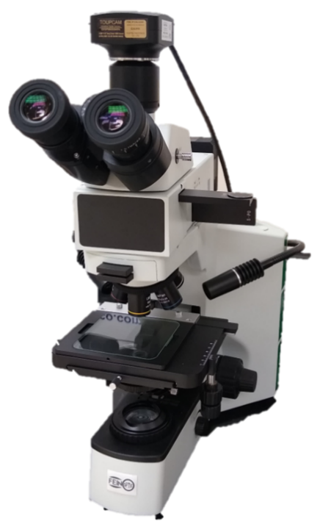
The IMA/USP 788 Digital Multipurpose Pharmaceutical Microscope.

Case Study

Water Wettability of Materials Quantified by Contact Angles
Water-resistant products are growing in the market, especially in the cookware and textile industrial segments. How do you determine your product’s water repellency or hydrophobicity? A common way to represent a product’s tendency to repel water from its surface is to determine the contact angle produced by water on the surface. Based on the results of a contact angle test, the attraction or repulsion of water by the surface, also known as wettability of water on the surface or hydrophilicity and hydrophobicity, can be quantified and determined.
A material is considered hydrophilic, or water attracting, if the contact angle made by water on the material surface is less than 90°. This means that the water will wet the surface of the material more easily. A material is considered hydrophobic, or water repelling, if the contact angle made by water on the material surface is more than 90°. This means that the surface of the material is not very wettable.
In this application note, water contact angles were measured for several common household materials: stainless steel, PTFE, polyurethane leather-substitute and rayon fabric, in order to determine their water wettability.
One of the most marketable features a household product can possess is an easy-to-clean surface. This is seen in the cookware industry where polytetrafluoroethylene (PTFE), commonly referred to as Teflon™, is used to make a piece of cookware “non-stick”. PTFE is added as a thin layer onto the surface of a metal substrate. This layer gains its functionality from the hydrophobicity of the PTFE material. Figure 1 shows recorded images and contact angle values of water on stainless steel and PTFE, respectively.
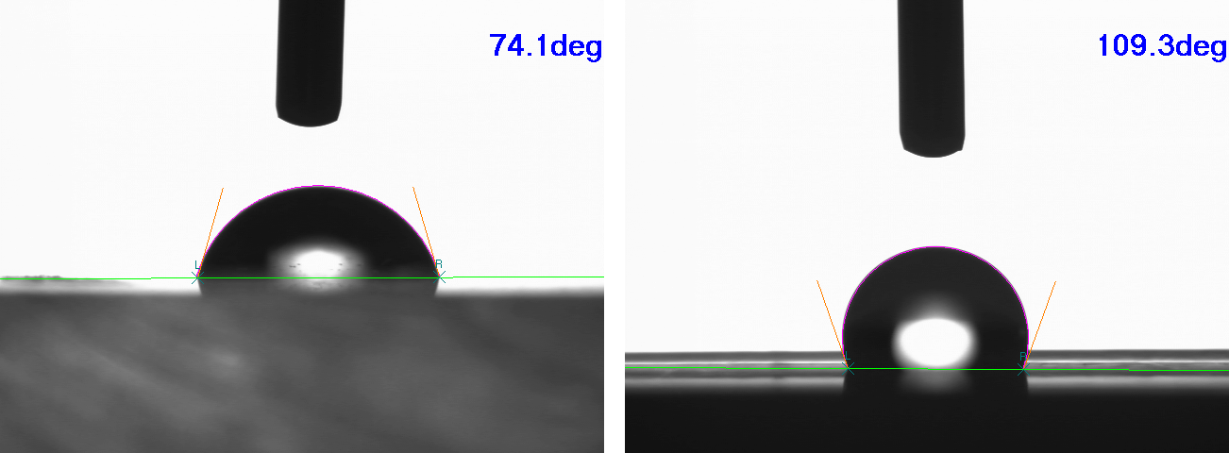
Figure 1. Contact angle between water and stainless steel (left), and between water and PTFE (right).
As can be seen from Figure 1, the contact angle of water on stainless steel is 74.1º, and the contact angle of water on PTFE is 109.3º. Due to these results, it can be said that the stainless steel is hydrophilic and PTFE is hydrophobic.
In the textile industry, it is desirable for clothing to repel water or sweat. Companies try to ensure that their weather-resistant clothing repels water so that it will allow rain and snow to roll off or slide down rapidly, not to dampen the product. Other companies are using hydrophobic materials to repel sweat so that in the hotter months the garment will be less likely to be wetted by perspiration. Figure 2 shows recorded images and contact angle values of water on polyurethane leather-substitute and rayon textiles, respectively.
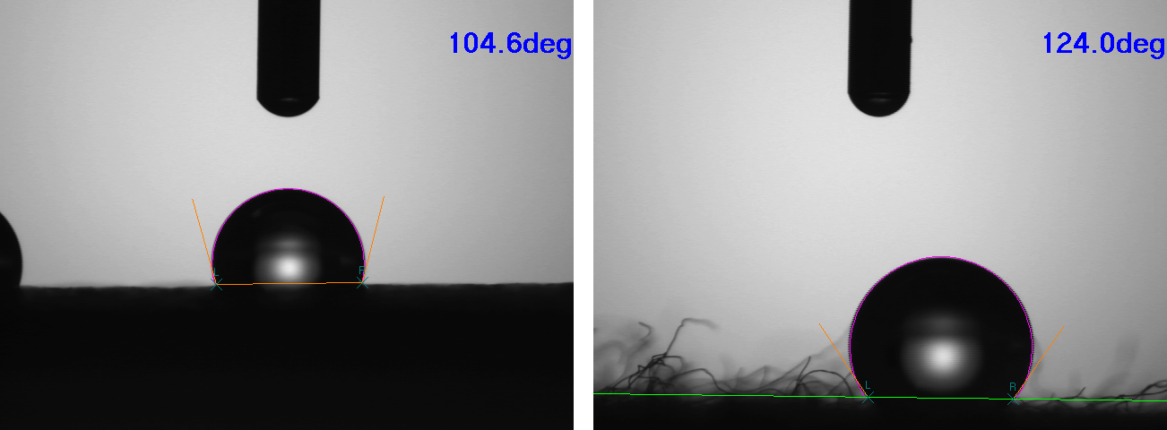
Figure 2. Contact angle between water and polyurethane leather-substitute (left) and between water and rayon fabric (right).

As shown in Figure 2, under ambient laboratory conditions, the contact angle of water on polyurethane leather-substitute is 104.6º, and the contact angle of water on rayon fabric is 124.0º. Based on these results, it is clear although both polyurethane leather-substitute and rayon fabric are hydrophobic, the latter will likely provide better performance with regards to water-resistance.
To subscribe or unsubscribe to this newsletter, contact info@ebatco.com.

Ebatco, 10025 Valley View Road, Suite 150, Eden Prairie, MN 55344
+1 952 746 8086 | info@ebatco.com | www.ebatco.com

