

Nano Brief
“Most of the transistors that are actually now inside your mobile phone have dimensions that are 22 to 28 nanometres in size.”

“And in fact the smallest dimensions might be as small as one or two nanometres.”

“So actually everybody is carrying nanotechnology around with them.”
-Professor Douglas Paul

Ebatco
The International Symposium for Testing and Failure Analysis, is running from November 9th through the 13th in Houston. For those attending, we will be exhibiting in booth #607 during the exhibition portion of the symposium. Please be sure to stop by if you can!

In our previous newsletter, we announced that we began a facility tour and demonstration of our company. These tours are ongoing and are available to anyone. We would like to thank all of those who took the time to take part in one of our tours. We hope the experience was informative and helpful. There is still slotted time for anyone who is still thinking about scheduling a tour and demo. Please contact us via phone or email or through our website www.ebatco.com at your earliest convenience. We would be more than happy to set aside some time just for you!

Case Study
Surfaces play a critical role in many applications. Controlling and measuring surface roughness is very important in applications such as precision position controls, semiconductors and astronautics. One specific example is within a combustion engine; the cylinder chamber surface requires a certain surface roughness to hold enough lubricants between the parts under compression while not too rough to induce metal-metal contact. Understanding the methods to characterize surface roughness is essential for quality control, failure analysis, design improvement, etc.

Surface roughness is usually characterized by several parameters such as average surface roughness (Sa), root mean squared, RMS, surface roughness (Sq), maximum peak height (Sp), maximum valley depth (Sv) and Peak-to-Valley Height (Sz). Among these parameters, Sa and Sq are used most often. According to ASME B46.1, Sa is the arithmetic average of the absolute values of surface height deviations from the defined mean surface. Sq is the root mean square average of the surface height deviation from the defined mean surface. Sq is more influenced by isolated large peaks or valleys than Sa.

Surface roughness can be measured by either contact methods or non-contact methods. For the contact methods, a component of the measurement instrument contacts the surface during the measurement. Such methods include mechanical stylus method and scanning probe microscopy. Contact methods can provide high resolution in both the vertical and lateral directions. However, a sharp stylus tip may cause damage to a soft sample surface. The non-contact methods are based on optical interferometry techniques. A major advantage for the non-contact methods is the ability to rapidly produce three-dimensional measurements, which is especially important for industrial applications. Nonetheless, if the surface has various optical properties or it is transparent or non-reflecting, the non-contact optical based methods may encounter difficulties in measuring and/or have inaccurate results.

Presented here are two surface roughness analyses; one for a wafer coating and one for a stainless steel sample puck. Both surfaces were scanned through in-situ scanning probe microscopy in a Hysitron TriboIndenter system. Both images have a scan area of 10 x 10 µm. The statistical results of the surface roughness were analyzed using Triboview software. The Sa, Sq and Sz roughness parameters were obtained for each surface.

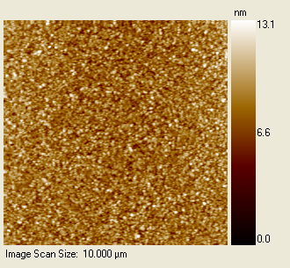
Sa  (nm) | Sq  (nm) | Sz  (nm)
1.05 | 1.32 | 13.01
Surface roughness analysis for a coated wafer surface.

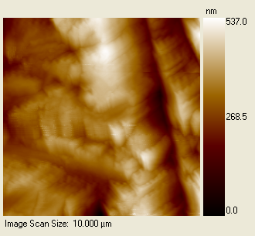
Sa  (nm) | Sq  (nm) | Sz (nm)
64.20 | 80.46 | 537.47
Surface roughness analysis for a stainless steel puck surface.

To subscribe or unsubscribe to this newsletter, contact info@ebatco.com.

Ebatco, 7154 Shady Oak Road, Eden Prairie, MN 55344
+1 952 746 8086 | info@ebatco.com | www.ebatco.com

