

Nano Brief
We will be representing Kyowa Interface Science at this year’s NIP 31 conference in Portland, OR. We will also have our new VPA-2 Peel Strength Analyzer on hand for demonstration. Our updated tradeshow and conference is as follows:

- September 27th – October 1st, NIP 31, Portland Marriott Downtown Waterfront Hotel, Portland, OR* representing Kyowa Interface Science, Co. Ltd.
- October 5th – 7th, Booth #629, Materials Science & Technology 2015, Greater Columbus Convention Center, Columbus, OH
- November 4th – 5th, Booth #1007, MD&M, Minneapolis Convention Center, Minneapolis, MN

We would also like to thank all the attendees of the BioInterface 2015 Workshop and Symposium for stopping by our booth during the conference. As always, please stop by and visit us if you are attending any of the above tradeshows. We hope to see you there!

Ebatco
Representing Ebatco, Dr. Dehua Yang, Founder and President, attended the BioInterface 2015 Workshop and Symposium that was held from September 21 to 23, 2015 in Scottsdale, AZ. Dr. Yang gave a presentation titled “Characterizing Biomedical Coatings Using Nanoindentation and Nanoscratch” at the Applied Technology Workshop during the BioInterface 2015. In his presentation, Dr. Yang first pointed out the significances of appropriate characterization of biomedical coatings/substrate systems, such as meeting product specifications, fulfilling quality requirements, understanding biocompatibility, increasing product reliability and user safety. Then Dr. Yang introduced advanced nanoscale analytical techniques for characterization of coating mechanical properties, steps on how to obtain accurate hardness and elastic modulus data from nanometer to micron thick coatings through nanoindentation tests, and interfacial adhesion evaluation of coating to substrate through nanoscratch tests. Dr. Yang’s presentation was very well received by over 100 biomedical engineers, research scientists, professors and graduate students in the related fields whom attended BioInterface 2015.

If you are interested in knowing more about nanoindentation and/or nanoscratch evaluation of thin films and coatings, please feel free to contact Dr. Yang at dyang@ebatco.com.

Case Study
Dielectric constant is a measure of a material’s ability to store electrical energy when placed in an electrical field. Also referred to as relative permittivity, the dielectric constant, ε_{r}, is the ratio of the capacitance of a material, C_{x}, compared to the capacitance of vacuum, C₀ with the same capacitor.
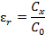
While the dielectric constants for most liquids are known, they may vary depending on impurities present in the liquid or if they are mixed with other liquids. Since there is no universal way to calculate the dielectric constant of a mixture, the best way to determine the dielectric constant is to measure the liquid mixture directly. This is especially useful for Zeta potential measurements where the liquid used to keep particles in suspension may be comprised of several different liquids.

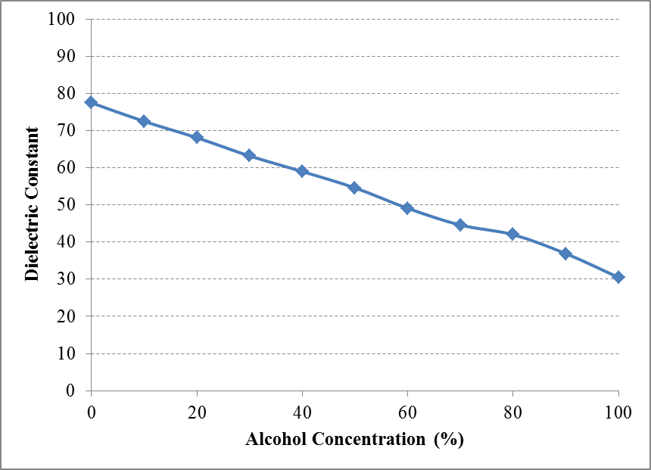
Dielectric constant of different concentrations of alcohol and water.
The Brookhaven BI-870 Dielectric Constant Meter equipped in Ebatco’s NAT Lab is capable of measuring the dielectric constant of a liquid. The BI-870 utilizes two stainless steel cylinders, one inner and one outer, as a probe. The probe generates a 10 kHz sine wave at the outer cylinder and measures the current between the two cylinders. By measuring the current, the dielectric constant can be readily measured.

The figure above shows the dielectric constants of various concentrations of denatured alcohol and water at room temperature. The results show a relatively linear relationship for the dielectric constant of water mixed with denatured alcohol. In this instance, the dielectric constant change as it related to the liquid concentration appears to be straightforward. However, for other mixtures, especially for more complex mixtures, this may not be the case. It is best to determine the dielectric constants of the liquids before their intended uses that could be influenced by their dielectric constants.

To subscribe or unsubscribe to this newsletter, contact info@ebatco.com.

Ebatco, 7154 Shady Oak Road, Eden Prairie, MN 55344
+1 844 3Ebatco (844-332-2826) | info@ebatco.com | www.ebatco.com

