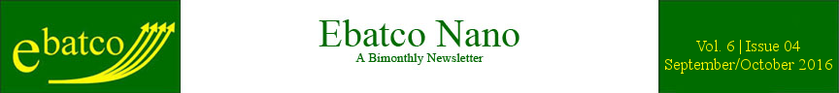

Nano Brief
The 2016 Nobel Prize in Chemistry was awarded to Jean-Pierre Sauvage, Sir. James Fraser Stoddart, and Bernard L. Feringa for the design and synthesis of molecular machines. To construct these nanoscale machines, a number of components need to be linked so that they can move relative to one another in a controlled fashion. To achieve this, the molecules need to be connected to each other mechanically, rather than through covalent bonds. In 1983, Jean-Pierre Sauvage and his team at the University of Strasbourg, France introduced a synthesis that used metal coordination to produce catenanes, two interlocked rings, easily and with higher yields. In 1991, Sir James Fraser Stoddart and his team at the University of Sheffield, UK developed a synthesis that “clipped” a cyclic molecule around an axial molecule with bulky endgroups, to prevent the rings removal, creating a rotaxane. In 1994, both research groups were able to demonstrate controlled motion by creating asymmetries in the molecular structures, and using electrochemical oxidation and reduction to generate motion. The two groups have continued to develop other, and more complex, molecular structures designed to perform work at the nanoscale. In 1999, Bernard L. Feringa reported the first example of controlled unidirectional rotation using isomerisable double bonds and cycles of light irradiation and thermal relaxation. His group then went on to anchor the motor, and use it to rotate micrometer-sized objects in a liquid-crystal film, as well as link four motor components together to create and propel the world’s first “nanocar”. These are extremely exciting developments in the world of nanotechnology, with the potential to be the foundation of another industrial revolution.

Ebatco
Ebatco is excited to announce the release of a series of videos about our company! The videos highlight the core values of Ebatco, commitment to customer satisfaction, our major contract lab services and available instrumentation. They can be viewed on our YouTube channel: https://www.youtube.com/user/ebatco. Please check out the videos and subscribe to our channel for more information about nanotechnology!

Case Study
Contact angle measurement by means of extension and contraction methods can be used to determine both advancing and receding angles. The advancing angle is the maximum contact angle possible for the liquid/solid surface system without increasing the interfacial contact area when the drop volume is continuously increased. The receding angle is the minimum contact angle possible for the liquid/solid surface system without reducing the interfacial contact area when the drop volume is continuously decreased. The difference between the advancing and receding angles is called contact angle hysteresis. The advancing and receding angles are sometimes referred to as dynamic contact angles because they can provide extra useful information in dynamic nature over static contact angle. For example, a small advancing angle is preferred in spin coating process for easy spreading of coating materials while a large receding angle is desired for chemical cleaning solutions for speedy drying up after the cleaning.

In the extension method, a droplet is first deposited on the sample surface. More liquid is then dispensed into the droplet and the contact angle is recorded over time. Eventually, the base of the droplet expands outward to compensate for the increase in droplet volume. The point where the base of the droplet starts to slide outward is where the advancing angle is recorded.

The contraction method is the extension method in reverse. Instead of adding liquid to the droplet, liquid is removed from a prepared droplet. Just as in the extension method, there comes a point where the base of the droplet begins to move inward. This point is where the receding angle is recorded.

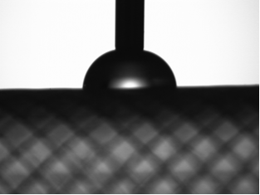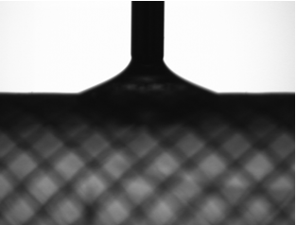
Images captured during advancing (left) and receding (right) angle measurements on the biomedical polymer catheter surface.

To perform the extension and contraction methods manually for advancing and receding angle measurement requires skill and steady hands. On the contrary, the DM-701 Contact Angle Meter, manufactured by Kyowa Interface Science Co., Ltd. is capable of performing the dispensing and aspiration of the liquid needed for the extension and contraction methods automatically. This automation minimizes the operator’s error and improves measurement repeatability significantly.

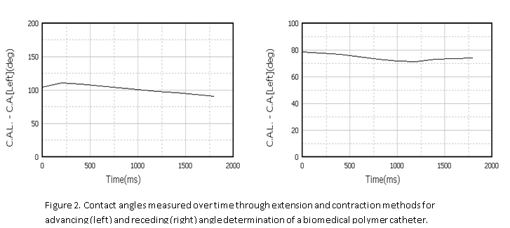
Contact angles measured over time through extension and contraction methods for advancing (left) and receding (right) angle determination of a biomedical polymer catheter.

In biomedical industry, catheters are often surface modified or coated to be lubricious and hydrophilic. Advancing and receding angles are measured for catheter surfaces in order to meet product specifications as well as to control interactions between catheter and patient body fluids during operation.

An uncoated biomedical polymer catheter tube was tested using the extension and contraction methods in our lab on the Kyowa DM-701. Some of the measurement results are presented in the figures. After the testing, it was found that the advancing angle was 110°. This is shown as the peak value in the contact angle vs. time graph in the right of the figure above. The receding angle was 72°. It is shown as the minimum value in the angle vs. time graph in the right of the figure above.

To subscribe or unsubscribe to this newsletter, contact info@ebatco.com.

Ebatco, 7154 Shady Oak Road, Eden Prairie, MN 55344
+1 952 746 8086 | info@ebatco.com | www.ebatco.com

