

Nano Brief
We would first like to thank the attendees of the inaugural Ebatco Academy Training Course on September 20th, which focused on the characterization and failure analysis of thin films and coatings. The session was well-attended by attendees from local and out of state industrial companies, instrument manufacturers and academic institutions. Thank the participants also for their great and constructive feedbacks. We hope to have more training courses like this one in the future. Please check back with us regarding the next course in the future.

Additionally, Ebatco will be exhibiting at these upcoming events:

- October 31st – November 1st, Medical Design & Manufacturing Minneapolis, Minneapolis, MN

- November 11th – 14th, National Association of Subrogation Professionals, Rosen Shingle Field Resort, Orlando, FL

Please stop by our booth to discuss the incredible world of nanomaterials, nanodevices, nanoinstruments, and nano/micro scale surface characterization with our staff scientists. We hope to see you there!

Ebatco

Congratulations to Dr. Dehua Yang who received his ASM International Fellow Award on October 16th at MS&T 2018 from then ASM International President, Dr. Frederick E. Schmidt, Jr.! The fellow awards were given to those with distinguished contributions to the materials science and engineering fields. The 2018 Class of ASM International Fellows inducted 27 members including Dr. Yang.

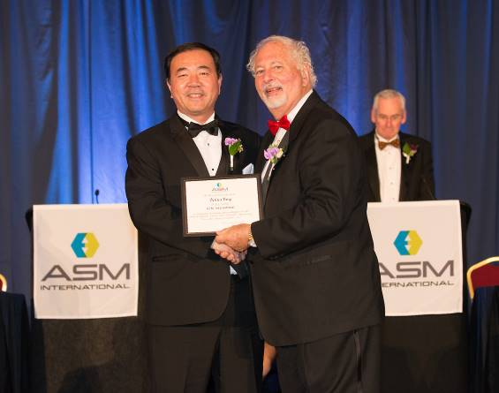

As we continue to grow our business we have hired on new talents to expand our expertise and testing lab service offerings. Please join us in welcoming the newest addition to the Ebatco team: Dr. Rebecca Tissot.

Rebecca Tissot received a Ph. D. in Materials Science from the University of Wisconsin, Madison in 2011 following her B.S. degree in Materials Science and Engineering at University of California, Berkeley. As part of her Ph. D. work on time-resolved synchrotron x-ray microdiffraction studies of piezoelectric thin films, she designed and led experiments at the Advanced Photon Source, the Brookhaven National Synchrotron Light Source, and SPring-8 in Japan. Following her graduation, Dr. Tissot worked in postdoctoral positions at Drexel University and Argonne National Laboratory. As secretary of the Postdoctoral Society of Argonne, she helped provide career development opportunities for the 300+ members of the postdoc community. She moved to Minnesota in 2016 to develop growth processes and characterization methods for high temperature superconductors for Quantum Designed Materials. Dr. Tissot joined Ebatco in September 2018 as a Materials Scientist and looks forward to working directly with customers and developing an x-ray characterization program.

Case Study

Tensile Fracture Failure Mechanisms of 316L Stainless Steel

The strength of manufactured materials, especially metallic materials, is a critical parameter to measure prior to the product reaching the market. One method commonly used to test the strength of a material is tensile testing. Tensile testing is often vital to ensure user and product safety, prevent liability concerns, and avoid non-compliance issues. When metal devices fail during the test, however, it is critical to determine the root cause of the failure to generate not only a stronger product but a safer, more effective one. As such, this application note describes the tensile fracture analysis of a product composed of 316L stainless steel.

The 316L stainless steel sample was approximately 10.5 cm in length and fractured under tension approximately 4 cm from one of the ends (Figure 1). As can be observed from Figure 1, the cross-section of the fracture is uneven, and slight necking is observed at the fracture position.

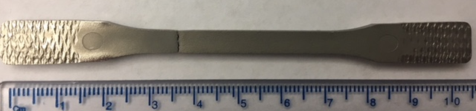
Figure 1. Image of the 316L stainless steel bar after tensile fracture.

To determine the failure mechanism, the fracture surface was initially analyzed via scanning electron microscopy (SEM). The SEM images at two different magnifications (250x and 1000x) of the center and the edge of the fracture are shown in Figure 2.

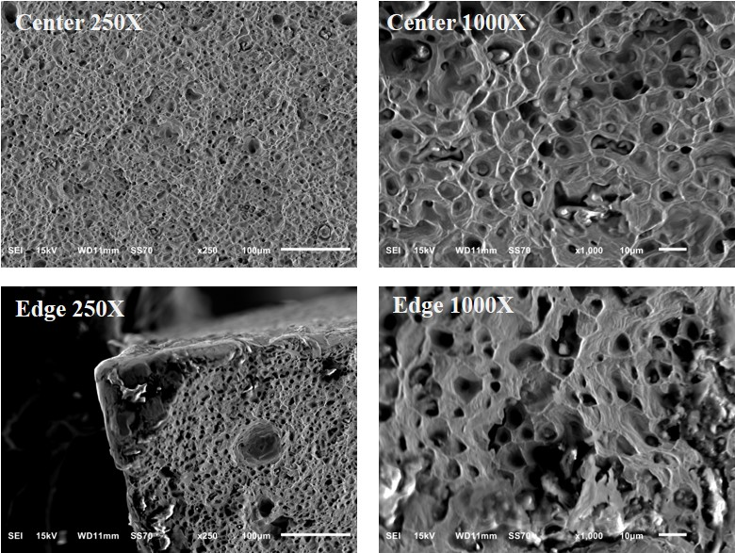

Figure 2. SEM images of the center of the fracture (top) and the edge of the fracture (bottom).

The SEM images in Figure 2 display a rough, dimpled morphology at both the edge and center surfaces, indicative of a ductile fracture. Particles were found at the base of these dimples, and the walls of these dimples had striped microstructures oriented perpendicular to the crack propagation front. Additionally, shear lips at approximately 45º angles were formed at the corners of the fracture. Based on these observations, the fracture was classified as a mixed-mode tensile fracture involving first a plane-strain fracture mode (mode I) and then a plane-stress fracture mode (mode II).

The first fracture mode initiated due to an increase in hydrostatic stress near the center of the sample. Microvoids then formed within the sample and coalesced to form cracks along the plane normal to the tensile load. Taken together, this is characteristic of a plane-strain fracture mode. This is further supported by the striped microstructures observed in the dimples, which suggest the presence of fibrous zones (Figure 2, right). As the propagation cracks approached the edge of the sample, 45º shear lips were formed, and the fracture mode changed from a plane-strain mode to a plane-stress mode (mode II).

To provide further insight, energy dispersive X-ray spectroscopy (EDS) was also performed on the fracture surface. Figure 3 shows the silicon and oxygen EDS maps on the fracture surface, and the images indicate the particles at the base of the dimples are SiO₂ inclusions. Originating from the stainless-steel manufacturing process, these SiO₂ inclusions must have been present in the initial austenite matrix. When the sample was stressed, the already-present voids near the inclusions grew to form dimpled microstructures around the SiO₂ inclusions. Based on the SEM/EDS analysis, the 316L stainless steel fracture mechanism was a combination of mixed fracture modes (mode I and II). Furthermore, the presence of SiO₂ in the austenite matrix facilitated the growth of microvoids, contributing to the cause of the fracture.

As observed, SEM/EDS analysis of fractures is a powerful method to determine failure mechanisms (and in this case contaminations) present in a failed product. This type of information not only aids manufacturers and developers to design safer, more effective products but also helps to avoid costly non-compliance and legal liability issues.

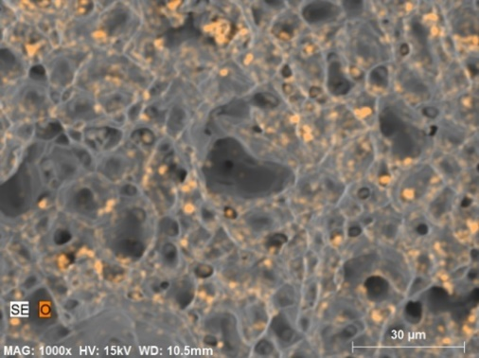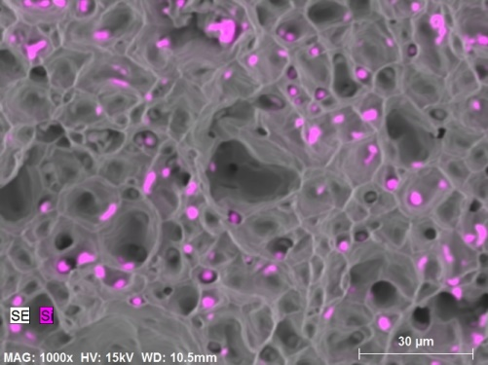
Figure 3. O and Si elemental maps of the 316L stainless steel fracture surface.

To subscribe or unsubscribe to this newsletter, contact info@ebatco.com.

Ebatco, 10025 Valley View Road, Suite 150, Eden Prairie, MN 55344
+1 952 746 8086 | info@ebatco.com | www.ebatco.com

