Nano Brief

Scientists from the University of Illinois Urbana-Champaign, University of California, Santa Barbara, and Dow have developed a breakthrough process to transform the most widely produced plastic — polyethylene (PE) — into the second-most widely produced plastic, polypropylene (PP), which could reduce greenhouse gas emissions (GHG). https://chbe.illinois.edu/news/stories/plastic-upcycling-JACS-2022

One class of methods for studying neural circuits is called voltage imaging. These techniques allow us to see the voltage generated by our brain’s firing neurons – telling us how networks of neurons develop, function and change over time. Recent research published in Nature Photonics, explores a new type of a high speed, high resolution and scalable voltage imaging platform created with the aim of overcoming these limitations – a diamond voltage imaging microscope. https://pursuit.unimelb.edu.au/articles/diamonds-reveal-neural-secrets

Ebatco

To further expand our ability to analyze samples for chemical analysis, especially for trace element analysis using ICP-OES (Inductively Coupled Plasma Optical Emission Spectroscopy) Ebatco has recently acquired a microwave digestion system. The ETHOS UP High Performance Microwave Digestion System manufactured by Milestone is capable of degrading regular molecules into its basic components in a matter of minutes with help of a max temperature of 240 C and 100 bar pressure. The system comes with hundreds of recipes for digesting a variety of samples and it can process samples in each of 8 vessels simultaneously.

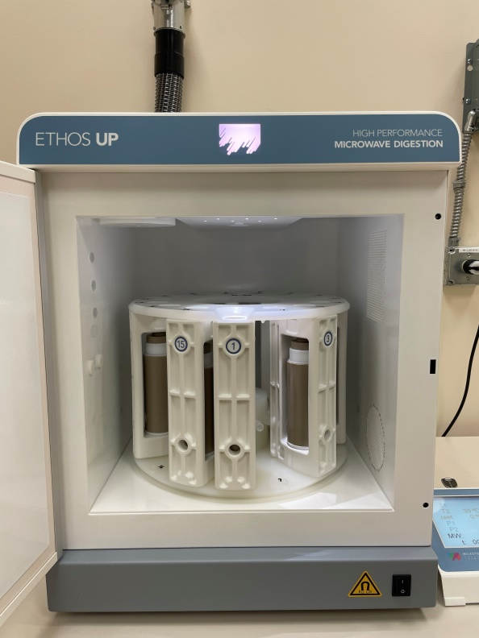
The ETHOS UP High Performance Microwave Digestion System

Case Study

Density and Surface Tension of Printer Ink
Inkjet printers can produce high quality pictures in a short amount of time. One important aspect to the print quality is the surface tension of the inks. Controlling the surface tension of the inks can help to improve their surface wetting properties to the printing media. One method to determine the surface tension of a liquid is the so-called Pendant Drop method. For surface tension measurements using the Pendant Drop method, a single droplet is suspended in air from a needle tip. The drop shape is then captured by a high speed camera for analysis. A fitting routine is used to analyze the captured image and determine the surface tension of the liquid.

The Pendant Drop method requires the density of the liquid to be known or measured. Other surface tension measurement techniques, such as the Wilhelmy Plate and du Noüy Ring, do not require the liquid density to be known. Nonetheless, the Pendant Drop method requires significantly less of a liquid sample for analysis. Just a few milliliters are sufficient for multiple surface tension measurements with the Pendant Drop method. In addition, the needle tip does not need to be cleaned using burning heat between measurements and is much more resilient to deformation than the Wilhelmy plate or the du Noüy Ring.

Two common printer ink colors are cyan and magenta. To determine the density, the cyan and magenta printer inks were measured with a DDM 2911 Density Meter manufactured by Rudolph Research Analytical (USA). Each ink was carefully injected into the Density Meter at room temperature. The results of the density tests for the cyan and magenta printer inks are shown in Table 1.

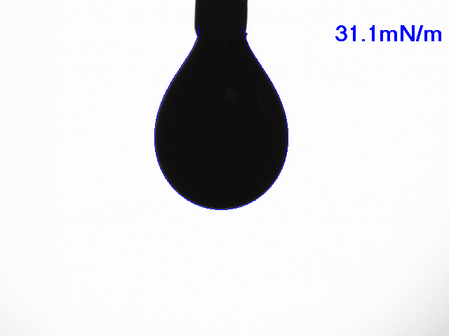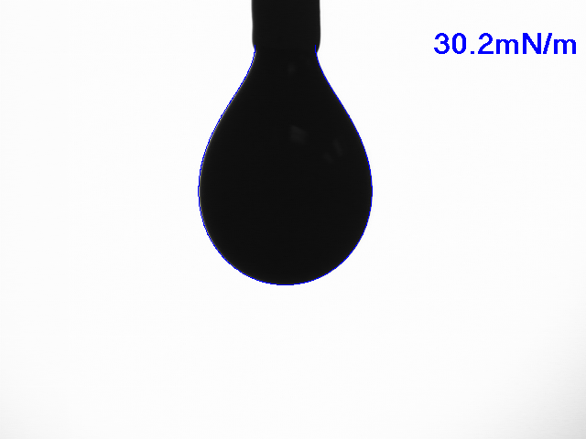
Figure 1. Typical image captures of the cyan (left) and magenta (right) printer inks used for surface tension analysis.

Table 1 Density Data for Cyan and Magenta Printer Inks
Printer Ink | Test 1 (g/cm³) | Test 2 (g/cm³) | Test 3 (g/cm³) | Average (g/cm³)
Cyan | 1.06773 | 1.06774 | 1.06774 | 1.06774
Magenta | 1.08215 | 1.08219 | 1.08220 | 1.08218

With the densities of both the cyan and magenta inks measured, the surface tension of each ink can be determined through the Pendant Drop method. The surface tension measurements were performed with a DM-701 Contact Angle Meter made by Kyowa Interface Science Co. Ltd. (Japan). The DM-701 allows for automatic liquid dispensing and drop size control. Figure 1 shows typical droplets formed by the cyan and magenta printer inks. The drop shapes were analyzed using the Young-Laplace theory.

Table 2 Surface Tension Data for Cyan and Magenta Printer Inks
Printer Ink | Test 1  (mN/m) | Test 2  (mN/m) | Test 3  (mN/m) | Ave.  (mN/m)
Cyan | 31.7 | 30.5 | 31.1 | 31.1
Magenta | 30.4 | 30.2 | 30.0 | 30.2

The surface tension for each ink was approximately 30 mN/m with the cyan ink being slightly greater in value than the magenta ink. Both measured surface tension values fall within typical surface tension values for printer inks. Even though the Pendant Drop method requires more information about the liquid properties to be known than other methods, it still has advantages over other surface tension measurement techniques for certain applications where liquid amount is rather limited.

To subscribe or unsubscribe to this newsletter, contact info@ebatco.com.

Ebatco, 10025 Valley View Road, Suite 150, Eden Prairie, MN 55344
+1 952 746 8086 | info@ebatco.com | www.ebatco.com

