Nano Brief

Scientists at the Columbia University, University of Connecticut, and the U.S. Department of Energy’s (DOE) Brookhaven National Laboratory were able to fabricate a pure form of glass and coat specialized pieces of DNA with it to create a material that was not only stronger than steel, but incredibly lightweight. Materials that possess both of these qualities are uncommon, and further research could lead to novel engineering and defense applications. The results were published in Cell Reports Physical Science.
https://www.bnl.gov/newsroom/news.php?a=221377
https://www.cell.com/cell-reports-physical-science/fulltext/S2666-3864(23)00254-0

A team of researchers led by the Harvard John A. Paulson School of Engineering and Applied Sciences (SEAS), the Wyss Institute for Biologically Inspired Engineering at Harvard, the Friedrich-Alexander-Universität Erlangen-Nürnberg in Germany, and Aalto University in Finland have developed a superhydrophobic surface with a stable plastron that can last for months under water.
https://seas.harvard.edu/news/2023/10/staying-dry-months-underwater
https://www.nature.com/articles/s41563-023-01670-6

Ebatco

Congratulations to Dr. Dehua Yang, Founder and President of Ebatco, for commencing his three-year term as a trustee serving on the ASM International Board of Trustees. It is a great honor and opportunity for Dr. Yang to rely on his material expertise, proven leadership and enthusiastic volunteerism to contribute greatly to the continuing growth and strength of ASM International.

Thank you to everyone who visited our booth at the MD&M Minneapolis 2023 and IMAT 2023 Meetings in Minneapolis and Detroit! It has been great to get back out to the show floors and meet people both new and familiar. We hope that through the interactions with Ebatco booth technical personnel you have learned more about how we could support your material and device testing needs. Please feel free to reach us at any time if you think we could be of your assistance. We also look forward to continuing our in-person scientific, technical and professional exchanges with you in the near future.

As we continue to grow our business, we have hired on new talents to expand our sales outreach. Please join us in welcoming the newest addition to the Ebatco team: Mr. Jonathan James, Technical Sales Engineer. Having received his BS and MS degrees in Materials Science and Engineering at Clemson University, Jon has over 20 years of experience in advanced materials and 10+ years in technical sales. He is passionate about providing innovative technology solutions to industrial customers across numerous sectors, with his efforts resulting in numerous patents and invention disclosures. As Technical Sales Engineer at Ebatco, he leverages his expertise in materials science, semiconductors, telecommunications, and medical devices to identify customer needs, present best-value products, and deliver unparalleled technical services. Motivated by the mission of Ebatco to serve the world's business and technology communities through its nanotechnology and materials expertise, he brings diverse perspectives and experiences to the team as a result of his academic and professional background. Jon is looking forward to making his first instruction call to you soon!

Case Study

Temperature Dependance of Peanut Butter Viscosity and Spreadability

How much effort is required to spread peanut butter across a piece of bread? Does peanut butter have the same viscosity or thickness when you chew it as when you spread it at room temperature? These are the types of product questions you can get answers for from rheological measurements, as rheology is the study of how viscous materials deform and flow. By design, peanut butter should be stable and appear solid in the container, but still spread easily and cling to the bread that you apply it to. These design specifications, characteristics and performances of the peanut butter products can often be tested and verified using laboratory rheology studies.

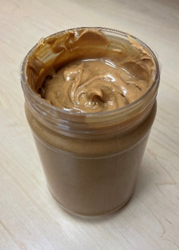
Figure 1. Peanut butter stored in a plastic jar.

The Ebatco newly acquired MCR302e Rheometer (manufactured by Anton Paar) is an excellent choice for characterizing deformation and flow properties of a variety of fluids and viscoelastic solids including peanut butters. MCR302e is capable of performing both rotational rheometry and oscillatory rheometry, using a wide range of shear stresses and shear rates in order to test viscoelastic behaviors of materials used in broad real-world applications. MCR302e with its heating and cooling stages can also allow explorations of the effects of temperatures on viscoelastic properties of materials from -150 °C to 400 °C.

In this application note, two commercial peanut butter products were evaluated on the MCR302e rheometer using a 25 mm parallel plate measuring system at 15 °C, 25 °C, and 35 °C so as to determine the effects of temperature on the viscous properties. These temperatures represent cold storage, room temperature, and the temperature when food is chewed, respectively. Each peanut butter was subjected to a logarithmic shear rate ramp from 0.01 s-1 to 10 s-1 to generate a viscosity flow curve. We were able to study the differences not only in viscosity at the selected temperatures between samples, but also in the yield point, the stress required to make the peanut butter flow.

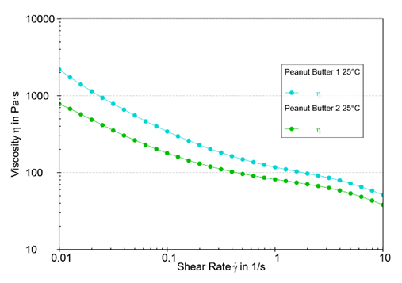
Figure 2. Viscosity comparison between two peanut butters.

The viscosity curves of both peanut butters at room temperature, as shown in Figure 2, are significantly different, possibly due to variations in their formulations. Peanut Butter 1 has higher viscosities for all shear rates than Peanut Butter 2 at room temperature. Thus, Peanut Butter 1 was determined to be harder to spread than Peanut Butter 2, which exhibited more of a whipped consistency.

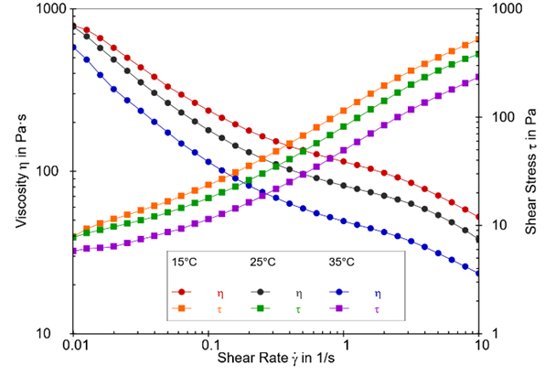
Figure 3. The effect of temperature on shear stress (τ) and viscosity (η) for Peanut Butter 2.

Both peanut butters were further evaluated to determine the influence of temperature on the initial yield point, the minimum shear stress required to generate flow. Yield points can be extrapolated several ways but for these experiments it was simply taken as the y-intercept from the plot of shear stress vs. shear rate at the lowest shear rate (Figure 3). The results determined this way for both peanut butters are listed in Table 1. As expected, increasing the temperature of Peanut Butter 2 reduced the yield point. It can be inferred that increasing the temperature of Peanut Butter 2 also increases the spreadability, as the peanut butter will not spread until the yield point has been met. On the other hand, Peanut Butter 1 exhibited higher yield point at all temperatures than Peanut Butter 2 and had slight increase in yield point from 15 °C to 25 °C before it had a significant drop in yield point at 35 °C.

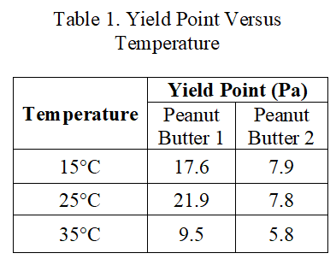
Rheometry can help to answer questions such as how the flow behavior of a product changes with temperature or with the addition of stabilizing additives, especially those that prevent phase separation. Useful rheometry data provides valuable feedback to the formulation team, thereby affording the team the ability to adjust the recipe proactively, reduce waste, and save time and money.

To subscribe or unsubscribe to this newsletter, contact info@ebatco.com.

Ebatco, 10025 Valley View Road, Suite 150, Eden Prairie, MN 55344
+1 952 746 8086 | info@ebatco.com | www.ebatco.com

