

Nano Brief
Wishing you a Happy New Year from all of us at Ebatco! May your 2014 be filled with success and prosperity!

2013 has been a wonderful and successful year for Ebatco. Under your enthusiastic encouragement and generous support, we have expanded and adapted to our new facility, welcomed and entertained a large group of customers at our very first open house, added two new staff members to our team, and acquired a whole new SEM/EDS system. Most importantly, we have gained many new customers for both our contract lab services and instrument products. Way to go, Ebatco! We are looking forward to the 2014 new year. In the new year, count on us, call us and work with us for any of your nano/micro analytical and testing needs!

Ebatco
For tests such as contact angle measurement, particle sizing and Zeta potential, the NAT Lab has had success with distilled water. In most cases, distilled water works well enough, but there are occasions where higher purity water is necessary. For those situations, the NAT Lab has acquired a Millipore Simplicity UV water purification system. The portable Simplicity UV water purification system produces Type 1 ultrapure water. This system will be useful for tests involving instruments such as the NAT Lab’s contact angle meters, micro contact angle meter, particle analyzers and surface tensiometers.

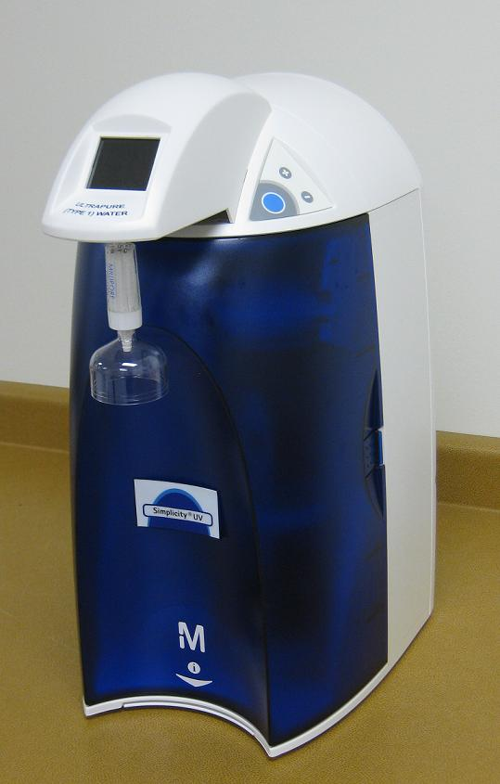
Millipore Simplicity UV Water Purification System.

Case Study
Coatings are used on a wide variety of substrates such as metals, alloys, semiconductors, polymers, biomedical devices for decorative or functional purposes. The adhesion behaviors of coatings are essential to their applications. Scratch testing is one of the broadly used, fast, and effective methods to evaluate coating adhesion properties. During a scratch test, a stylus or scratch tip gradually penetrates into a coating under a progressive load while it also moves across the coating sample. The normal load at which the coating fails due to delamination or other separation mechanisms is called the critical load of interfacial adhesion failure. The critical load of interfacial adhesion failure is related to the practical adhesion strength of the coating to the substrate. One complementary technique for analyzing scratch failure of coating is Scanning Electron Microscopy (SEM) equipped with Energy Dispersive X-ray Spectroscopy (EDS). Working in tandem, SEM and EDS analyses can reveal a tremendous amount of useful information on scratch failure processes and mechanisms, as well as material anti-scratch properties. With the SEM system, micrographs can be taken for morphological inspection in order to understand how the scratch surface is forming and changing. The SEM micrographs of the scratch surfaces can reveal much more details as a result of SEM’s larger depth of field, higher resolution and greater magnification than the optical microscope available on a scratch tester. In addition to SEM observations, the EDS system can further assist in identifying and quantifying the chemical compositions of the micro areas of interest by measuring the characteristic X-rays produced by atoms that are present in the coating and substrate materials.

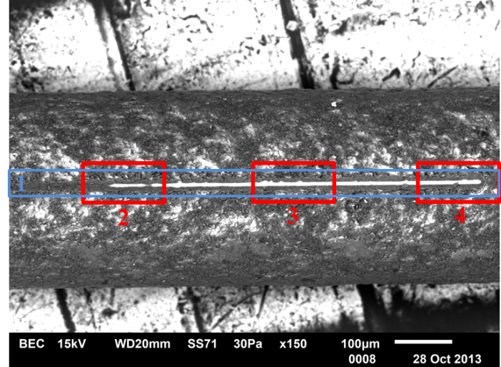
SEM image of a PTFE coated stainless steel guide wire after scratch test; scratch direction: left to right; scratch tip: 2µm diameter, cono-spherical diamond tip.

PTFE coated stainless steel guide wires are popular in many medical applications. PTFE coatings are applied to the wire surface for smooth surface finish, reduced friction, increased lubricity and durability of the guide wire. Obviously, the PTFE coating adhesion to the guide wire is critical not only for the desired functionalities but also for the health and safety of the patient to whom the guide wire is to be used. An undesired issue would be flaking of the coating material due to adhesion problems, which could lead to blockage of a passage or clogging of blood vessels. The above figure is an SEM image of a PTFE coated stainless steel guide wire after scratch test. Blue color box Zone 1 includes scratch before interfacial adhesion failure, transitional Zone 2 in which adhesion failure occurred, steady scratch Zone 3 and scratch end Zone 4. The bright scratch track in Zones 2-4 indicates non-existence of the PTFE coating and exposure of the stainless steel substrate.

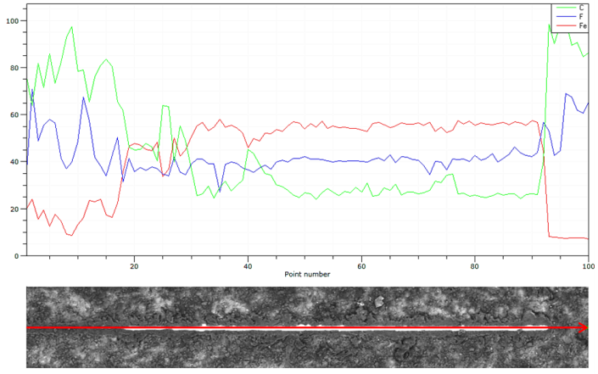
EDS elemental concentration profiles along the red scan line in Zone 1.

The above figure shows the elemental profiles of Zone 1 with the EDS line scanning across the entire scratch. The EDS compositional analysis has verified the morphological interpretations of the SEM image; the coating has in deed delaminated in Zone 2 where element Fe (red line) from stainless steel substrate increases and C (green line) and F (blue line) from the PTFE coating decreases. The zoom-in SEM images and EDS elemental Hypermaps of the Zones 2-4 presented in the figure below provides further details of the elemental distributions of the coating and substrate materials along the scratch.

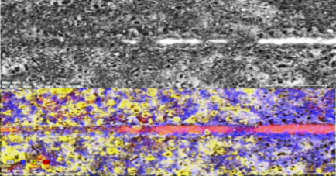
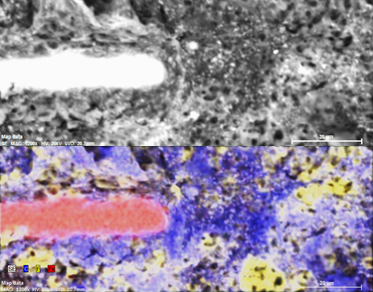
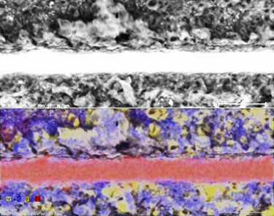
SEM images (top half) and EDS elemental Hypermap (bottom half) of Zones 2-4; C (blue), F (yellow) and Fe (red).

To subscribe or unsubscribe to this newsletter, contact info@ebatco.com.

Ebatco, 7154 Shady Oak Road, Eden Prairie, MN 55344
+1 952 746 8086 | info@ebatco.com | www.ebatco.com

