

Nano Brief

Dear Customers and Friends:

Another year has gone by. Our success in 2015 is the direct result of your strong support, your generous business, and your continuous encouragement. We thank you from our heart! We wish you a happy holiday season!


Ebatco
As we continue to grow our business, we have hired on new talent to help with performing lab work, and any other tasks when needed. Please welcome our new addition to our technical team: Mr. Devin Williamson. Welcome onboard!

Mr. Devin Williamson is a recent graduate from the Materials Science and Engineering program at the University of Minnesota- Twin Cities campus. He greatly enjoyed working in a lab environment while he was in school, especially utilizing SPM and SEM techniques to analyze samples on a microscopic scale, and is excited to continue this type of study as a professional.

Case Study
Energy Dispersive X-ray Spectrometry or EDS Analysis has become an essential tool for metallurgical analysis. EDS has been used for many decades to detect, identify, and quantify elements by their characteristic X-rays emitted during electron bombardment of a specimen surface. Recent development of silicon drift detectors have significantly increased count rate throughput of EDS systems so that elemental mapping can be carried out in a more practically efficient way. An EDS hypermap that contains the surface chemical compositions and their distributions may be overlaid with a secondary or backscattered electron image for enhanced metallographic study. EDS analysis is especially powerful to analyze the chemistry of non-metallic inclusions, to show distributions of low content alloy elements, and to meaningfully identify grain and phase structures.

Ebatco’s NAT Lab is equipped with a state-of-the-art, low vacuum JEOL JSM-6610LV Scanning Electron Microscope (SEM) with a Bruker QUANTAX 200 EDS system. The EDS system is equipped with an XFlash 6 | 30 SDD. The EDS system is optimal for both micro and nano analysis, and spectral imaging with precision, accuracy, and efficiency.

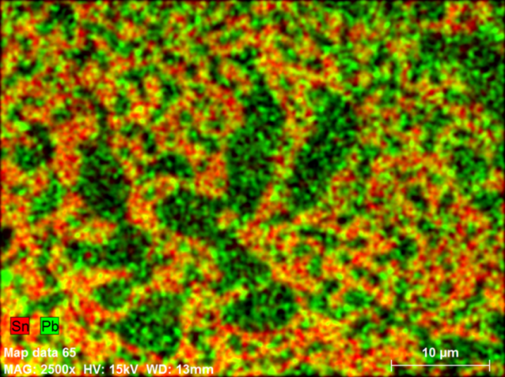
EDS elemental hypermap of Pb-Sn solder

The above figure shows that the Pb-rich α phase is in the center and lamellar Sn-rich eutectic phase is in the surrounding area. The composition of the primary alloy phase is related to the eutectic phase transformation at 62 wt% Sn and temperature of 183°C. Since this temperature is considerably lower than the solidification temperatures, 232°C for pure Sn and 327.5°C for Pb, when the alloy liquid cools from the melt it forms a primary solid phase above the eutectic temperature. The composition of the primary solid phase depends on the alloy content. If the Sn content of the alloy liquid is less than 62 wt%, the Pb-rich α phase forms first, otherwise the Sn-rich β phase forms first. As solidification proceeds to the eutectic temperature, the eutectic phases α + β start to form in the surroundings of the primary solidified primary phase. In this study, the EDS element map clearly shows the primary phase is Pb-rich α phase, which indicates that the Sn content of this alloy is less than 62 wt%. Further EDS analysis in the figure below confirms this fact. The weight percent in that analysis shows that the solder is 60.45 wt% Sn.

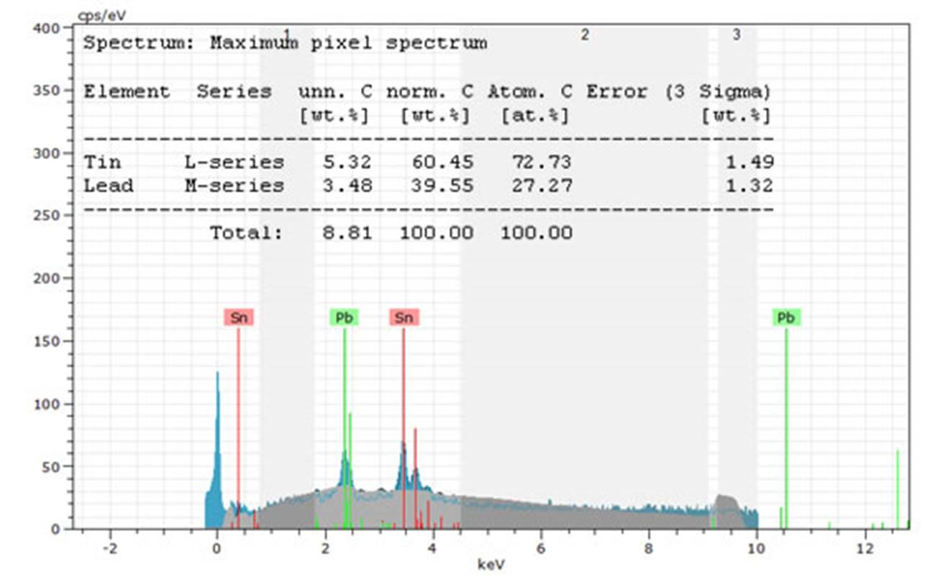
EDS spectrum and elemental analysis of a Pb-Sn solder.

To subscribe or unsubscribe to this newsletter, contact info@ebatco.com.

Ebatco, 7154 Shady Oak Road, Eden Prairie, MN 55344
+1 844 332 2826 | info@ebatco.com | www.ebatco.com

